Submitted for the Degree of B.Sc in Computer Science, 2014-2015

**Who will win the tennis/football/cricket?**

201140666 Craig William Thomson

Except where explicitly stated all the work in this report, including appendices, is my own and was carried out during my final year. It has not been submitted for assessment in any other context.

I agree to this material being made available in whole or in part to benefit the education of future students.

Signature: Date:

# Abstract

Online sports betting has had a large increase in popularity in recent times. In-Play betting has become one of the most popular betting areas which is now commonly supported. Whilst a game is in play there can be up to tens of millions of pounds bet on its outcome through in-play markets alone. Betfair is the worlds largest betting exchange and it is one of the largest proponents of in-play betting, providing a large selection of in-play markets to bet on during a games duration.

The aim of this project is to create a basic probability model of one or more games that Betfair supports gambling on. It will then examine the changes in probability that occur whilst the game is in play and attempt to re-create significant match events (goals, points, runs etc.) from the changes in probability detected.

# Acknowledgements

I would like to thank my supervisor, Professor Richard Connor for his help throughout the duration of the project and I would also like to thank my second marker Dr Murray Wood for his useful suggestions on the poster day.

Table of Contents

Abstract 2

Acknowledgements 3

Introduction 6

Objectives 7

Outcome 7

Report Structure 7

Related Work 8

Tennis Modelling 8

Betfair API 9

Betfair Overview 9

Terminology 9

API Overview 10

listEventTypes 11

listEvents 11

listMarketBook 11

listMarketCatalogue 11

API methods in action 11

Sport Viability 12

Criteria 13

Football 14

Tennis 16

Rugby 18

Basketball 20

Others 22

Decision 22

Market Viability 23

Problem Description and Specification 28

Description 28

Specification 28

Approach 31

System Design 32

Calculating implied probability 32

System breakdown 33

Data Analysis 34

The Predictor 34

The GUI 35

Summary 37

Detailed Design and Implementation 38

Detailed system diagram 38

Basic Class Diagram 39

Implementation Language 39

Design Choices 40

Observer vs Shared Memory 40

TimerTask vs Thread 41

Design Patterns used 42

Observer 42

Template 42

Factory 42

3rd party libraries used 43

JFreeChart 43

JCOMMON 43

GSON 43

Apache HTTP Components 43

Initial System 43

Components 44

Collector 44

Analysis 45

Predictor 46

GUI 49

Implementation Issues 51

Summary 51

Verification and Validation 52

Black Box testing 52

GUI 52

Predictor/Whole System 53

JUnit Testing 55

Results and Evaluation 55

How well it meets the specification 55

Performance Analysis 57

Conclusions 58

**Success of achieving aim** 58

**Problems** 58

**Future Work** 58

Appendix 1 References 59

Appendix 2 Betfair API examples 60

Appendice 3 Initial Project plan 75

Appendix 4 Market Matched Data 76

Appendix 5 Market Listings 80

5.1 Most markets for a game 80

5.2 The minimal number of markets for a game 82

Appendix 6 Detailed Class Diagram 83

Appendix 7 Match Odds Graph Examples 84

Appendix 8 Test Cases 86

**Appendix 9 User Guide** 92

# Introduction

Betfair is the worlds largest online sports betting exchange and the biggest online betting company in the United Kingdom. In 2014 it reported having over a million active customers and nearly £400 million pounds in revenue (Betfair, 2014). With the huge number of active users and the amount of revenue it generates, it deals with a huge number of bets on a daily basis on a large spread of games and markets on a daily basis. In 2012 Betfair opened up access to their Exchange API to any registered user on their website (ComputerWorldUk, 2012). The API allows users to access their internal exchange databases and allow the reading of betting data and automation of betting functions that are provided by their website. It was created so that developers could create custom applications for Betfair users. The API provides numerous research opportunities because they allow complete access to all of their betting data. It has been used for research into market modelling, predicting future odds and much more.

In this project the Betfair Exchange API will be used to create probability models of sports based on the chances that certain game events occur. The goal is to create an application which will run, only using real Betfair data, convert the data into probabilities, detect changes in the probabilities and it will attempt to predict what event in the game caused the change, with some degree of accuracy.

## Objectives

The primary objective was to create a probability model for at least one sport and then design and implement an algorithm that can be applied to the probabilities to semi-accurately predict what occurred in the game that caused the change in probability. The high level objectives are listed below

* Create a system that interfaces with Betfair and collects raw odds data
* Analyse the collected data and decide which sports are viable for modelling and prediction
* Identify markets in the sports that would be modelled to decide the events that will be possibly predicted
* Gather a larger data set from the API for selected sports
* Design and implement a probability model
* Design and implement a prediction algorithm that can be used to predict game events from the changes in probabilities that it’s given

## Outcome

Various sports were examined for viability for this project and Football was the chosen sport. The game events that were to be predicted were decided after additional data was collected and analysis was performed. The events are goals, half time/game ending, red cards and some indication of who possibly scored the first goal in the game. A prediction algorithm was designed and implemented for Football. A program was produced which takes data from the Betfair API for various markets in a game, converts it to probability and examines the changes. It is fairly accurate at being able to predict the selected events for most games.

## Report Structure

This report will detail the work that was performed during the time period that this project was completed. It is a record of all of the work that has been performed during the projects lifespan. The following chapter will detail the research that was performed in the early stages of the project. Then there is a chapter which details the analysis performed before selecting a sport to model. There is then a chapter detailing the specification which includes the list of functional requirements amongst other things. Further on there are chapters regarding the implementation in detail, verification and testing and finally the overall evaluation.

# Related Work

This chapter will detail the initial background research that was performed regarding the main topics of the project. These are the investigation of sports game modelling, research on the abilities of the Betfair API itself and looking at projects with similar goals.

## Tennis Modelling

During background research, a paper with similar goals to this project was found (Huang 2011). The focus of the project was on tennis, where the goal was to see if they could infer the score in a game of tennis purely through the analysis of the odds through the games duration.

The work described in the report is more complex than what the goal of this project aims to achieve. A hierarchical Markov tennis model was created in order to calculate the match winning probability of a player. It was then used in conjunction with implied probability of winning in order to decide the score of the game, throughout its duration. The content of the report created various useful thinking points for this project. Huangs work was completely focused on Tennis but some of the information presented is highly transferable to this project. The chapter on using the Betfair API for data extraction is particularly useful because it explores the topic of deciding which values to use for calculating implied probability, previously matched values or the back-lay average. It also raises the relevant topic of false-positives and discusses possible heuristics for detection of events, false-positives and analyses the effectiveness of the algorithms.

It provides proof that the aim of this project is possible, at least for the sport of tennis. Which is encouraging, considering that the aim of this project is to investigate sports for viability and then create a program which can predict purely from Betfair data.

## Betfair API

### Betfair Overview

Betfair is largest online betting company in the UK and the largest betting exchange in the world. It differs from traditional bookmakers because it’s a betting exchange rather than a bookmaker. The difference is that with a bookmaker, if a user wishes to put a bet down then their options are what the company puts the odds at and depending on the games result the bookmaker either pays out or received the stake. With a betting exchange, the company acts as the middle man, they allow users to take the place of the bookie. For example if User 1 puts down a bet for team A to win then the exchange will attempt to match them with someone who’s betting with the same odds that team A will lose. If a match is found then the bet will be accepted and the stake will be transferred from the losers account to the winners. The exchange operates by matching up users bets and taking a commission, typically 5% [Betfair, 2014b].

### Terminology

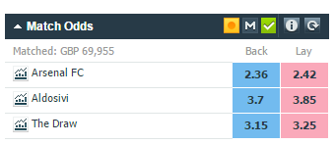

The above market is the Match Odds market for Arsenal FC vs Aldosivi. The Match Odds market is essentially the market for betting on the overall result of the game. So in this market there are 3 runners: Arsenal, Aldosivi and The Draw. Below the terminology will be explained

Back – If the user wants to back Arsenal FC then that means that they are betting that Arsenal will win the market, thus win the game. The value displayed (2.36) is the best available odds that a user can back Arsenal for. It’s the best available because those odds are what another user has put down for a lay. So in this situation some user has put down to lay Arsenal FC with the odds of 2.36 (betting that Arsenal doesn’t win). So what Betfair is doing here, is displaying the highest possible odds that you can back that will instantly match you with another users lay. So if a user puts down £1 on the offered odds and their runner wins then they will get £2.36 back where £1.36 is profit.

Lay – If a user wants to lay Arsenal FC then that means the opposite of above. Betting to lay a runner means that that user is betting that the runner doesn’t win. The value displayed (2.42) is the best available odds that you can instantly bet and be matched with another user for. The value is actually the odds of the best unmatched back.

To summarise, the odds shown in the back column for a runner are the odds that the best unmatched lay is for. The odds shown in the lay column are the odds that the best unmatched back is for, and Betfair works as an exchange by providing these options to users in order to quickly arrange bets. Users aren’t limited purely to the listed numbers above for betting, they can put in their own custom odds which may eventually be matched, as the game state changes, but not at that exact instant of time.

### API Overview

In 2012 Betfair provided users’ free access to their API, where before it was limited to users in their developer network (ComputerWorldUk, 2012). API access was made free so that developers, both private and commercial could create custom applications providing access to Betfair, so that their potential profits could increase. Betfair also provides developers large amounts of historical time stamped data (Betfair, 2015a) to assist them in creating their applications, but this data is only available to those who are registered Betfair developers or have bet a fairly large sum on money on the website. The fact that it isn’t free is the reason why data collection is a large part of this project. This data Betfair now has 4 different APIs that users can access (Betfair, 2015b). The API of interest for this project is the Exchange API. The Exchange API allows direct communication with the Betfair internal databases, which in turn allows functionality typically not available on their website. Betfair provides 15 different methods for accessing different types of data from their database which have some documentation (Betfair, 2015c). The methods of interest, which are used in this project, are listed below with a brief summary.

All requests and replies to the Betfair API are in JSON notation.

### ****listEventTypes****

**The listEventTypes method requests the Betfair API for a list of all events that betting is currently supported for. In returns sport names along with their associated ids (event type ids) and the number of active games, of that sport, that are currently open for betting. The event type ids are needed for any further request that’s specific for that sport (see listEvents). See appendix 2 for JSON example of request and reply.**

### ****listEvents****

**The listEvents method requests the Betfair API for the list of all open games which have open betting markets, for the given event type id(s), which are a required parameter. An additional parameter required for this call is a time range, which is used to restrict the results returned by only returning those that start within the given time. The method returns a list of events (games) with their names, event ids, number of markets available for betting and other data. See appendix 2 for JSON example of request and reply.**

### ****listMarketBook****

**The listMarketBook method requests the list of available markets for betting for the given event id. It returns a list of market ids, market names, start times and other data of interest. See appendix 2 for JSON example of request and reply.**

### ****listMarketCatalogue****

**The listMarketCatalogue method requests live market data for the given market id(s). It returns a list of results for each requested id. Inside these lists are the market ids, the market status, information about back and lay bet options for its runners and other information. See appendix 2 for JSON example of request and reply.**

### API methods in action

Below is a diagram of how the above methods interact with each other.

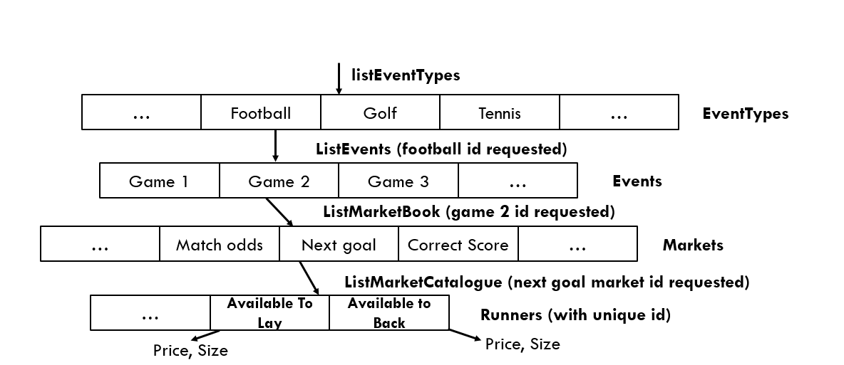

# Sport Viability

Initially there were 4 Sports that were examined for viability for this project. The viability of each Sport was assessed by investigating how well they passed a predefined set of requirements (listed below) and by what a graph of probabilities over time looked like for the Match Odds market. Every game on Betfair has a Match Odds market and it’s typically the most highly bet on market too. How a sports Match Odds graph looked had more weight in the decision of whether or not it’s viable than how it met the criteria. This is because the Match Odds graph is going to be one of the markets assessed for predictions, no matter which Sport is selected, so the more clear-cut changes in probability on it are meant that it’s more likely that an accurate prediction model could later be created for it as opposed to a game where teams probabilities are constantly overtaking each other.

This section will examine some of the most popular sports that Betfair allows betting on, explore the criteria for eligibility and it will examine sports under this criteria and their Match Odds graph in order to decide which are viable for this project. Betfair provides betting support for approximately 48 different “sports”, ranging from Football to Chess. (Betfair, 2006) The next section details the process of deciding the criteria selected and the reasoning behind it. Following that is the section where individual Sports are analysed. At the end is a small section detailing the chosen sport and the reasoning for the decision.

### Criteria

**Duration**: Game duration is an important factor when it comes to initially deciding if a game can be successfully modelled or not. Games which span days aren’t viable for recording and there’s little interest for anyone to observe a game for days using this program. Another challenge is attempting to resolve timestamps from received data to actual game time. Ideally a games duration will be 1-4 hours. This is long enough so that there is decent depth to the game, so that there’s going to be lots of information available for collection for analysis. The game length must be long enough so that a reasonable number of sports fit in its criteria, whilst filtering out clearly unsuitable sports that have too long of a duration (golf for example).

**Number of markets**: The more markets that a game has means the more possible events that can be extracted. For example football has markets such as first goal scorer, second goal scorer, sending off and yellow cards whilst golf markets are only for who wins the tournament. Obviously by looking at the number of markets available, depending on other factors, there is much more potential information extractable from football than golf, as a game is in play.

**Amount bet**: The amount of money that’s bet on a market is a huge factor when it comes to the process of deciding eligibility of sports. A sport where its most highly bet on game has at most £20,000 is spread across all of the markets is clearly less promising than another sports game that has £2,000,000 spread across its markets. By using the assumption that users are knowledgeable, then the more money bet on a game, which slowly increases over time, means that the odds offered for bets are more reactive to the game state than those with less money bet. This ignores the most likely impossible case that the only reason a games got a lot of money bet on it is due to very few large bets rather than lots of smaller ones.

**Market activity:** Market activity in this case means activity across all of a games markets, rather than activity of a single market. Games which have activity across many of its markets are promising because typically, various different amounts of information can possibly be extracted from changes of probability in different markets. For example activity in Match Odds, sending off, penalty taken, and first goal scorer creates a larger set of possible inferred information than a game with activity in only Match Odds.

### Football

Football is a sport that fits well with the listed criteria. It has the highest TV viewership numbers of any other sport in Britain (Ipsos-MORI, 2003). In terms of game duration football is played over 2 halves of 45 minutes with extra time per half. In addition to this, the game has a 15 minute half time, thus taking up approximately 105 minutes plus extra time from start to finish. This fits well within the previously stated time scale. Football also has the most markets available for betting of any given sport supported by Betfair. The number of markets for a football game depends on its popularity, Barclays Premier League games can have up to 94 markets open[Appendix 4.1] whilst games in the Hong Kong Football league have as little as 14[Appendix 4.2]. The huge number of markets available for football betting makes it a promising sport for this project. It also has a respectable amount of money bet on it, fulfilling the Money bet criteria. The Match Odds market is the most heavily bet on market for football games, and it is one which every game has. Match Odds is the market for betting on the final outcome, team a wins, team b wins or draw. Match Odds typically has at least £100,000 bet on it for most games and over £2,000,000 for some. The amount of money bet on a football game tends to be fairly well distributed. The most commonly bet on markets appear to be Match Odds, Over/Under x goals and correct score along with others. The diversity of the markets bet on for football makes it a promising looking sport.

Below is a graph of the Match Odds market for the game Italy vs England (31/3/15)

The game result was a 1-1 draw. Italy scored first.

Note that probability points of 0 on the graph exist when there isn’t a back/lay available for the runner.

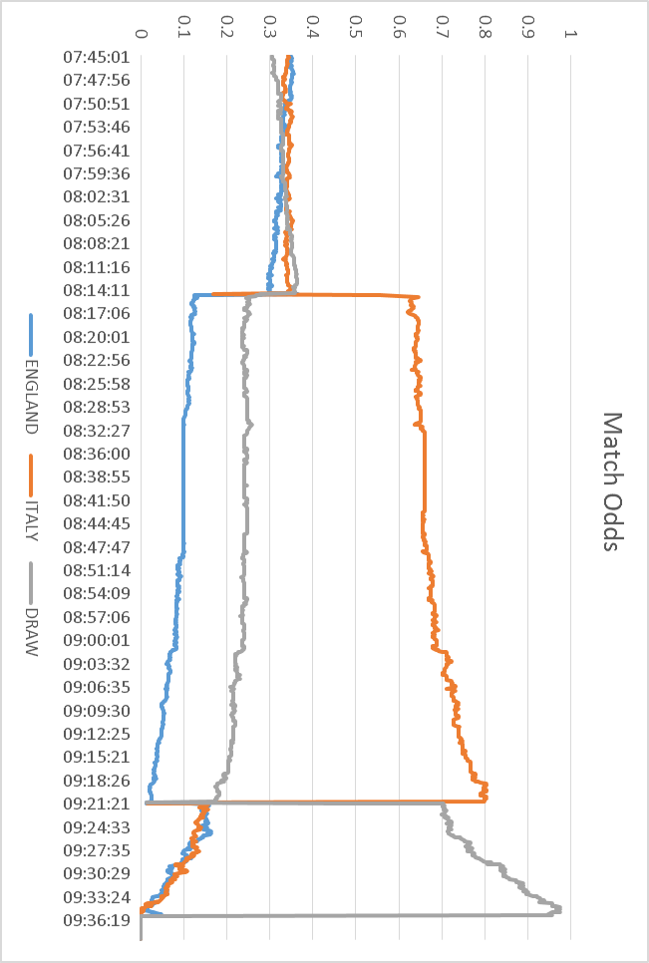

### Tennis

Tennis matches are on the edge of the time limit, typically taking 3-4 hours and sometimes longer. Betfair typically supports a good number of tennis markets, allowing betting on the winner to individual set scores. This means that there’s a possibility that set specific information could be extracted. Tennis leads all other markets on Betfair when it comes to the amount of money bet on it. Some Tennis tournament games can have over £10,000,000 bet on the Match Odds market alone, making it a good possible candidate. Market activity is where tennis falls short. Huge sums of money are usually bet on the Match Odds market whilst the other markets have significantly less, making it seem less likely that a lot of additional information could be extracted.

Below is a graph of the Match Odds market for the game Djokovic vs Dolgopolov (31/3/15).

Djokovic won 6-7(3), 7-5, 6-0.

Note that probability points of 0 on the graph exist when there isn’t a back/lay available for the runner.

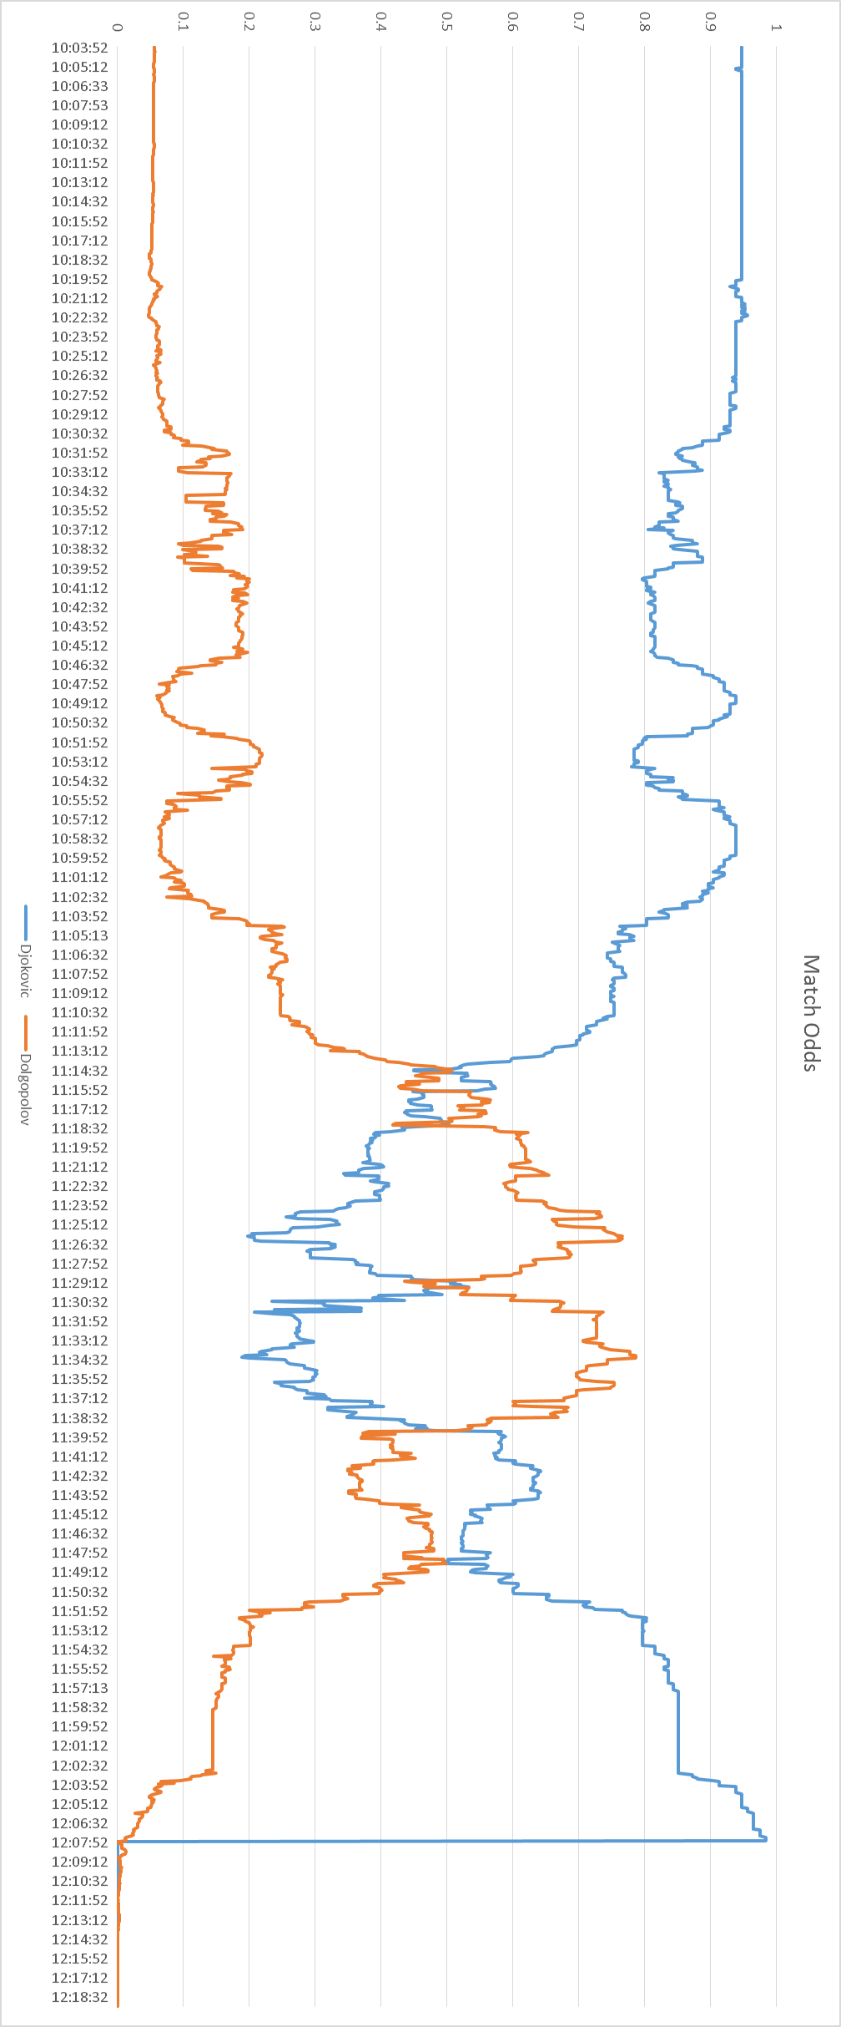

### Rugby

International Rugby union games are the targets, if it is the selected Sport for this project. Rugby games are a good fit in the time requirement, taking approximately 90 minutes for a game. International Rugby Union is the focus because there’s significantly more money bet on those games than the typical Rugby League game. There’s a quite sparse number of markets available for Rugby, ranging from betting on the first try scorer to the approximate number of points that a team scores in a game. This means that there’s a possibility of being able to predict quite game specific information from the extracted data.

Below is a graph of the Match Odds market for the game England vs France (21/3/15). England won 55-35.

Note that probability points of 0 on the graph exist when there isn’t a back/lay available for the runner.

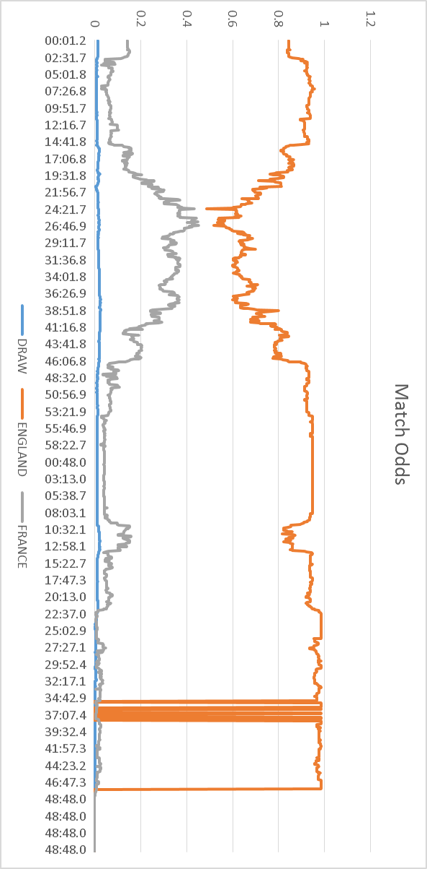

### Basketball

Basketball is played in 4 quarters of 10 minutes with breaks in between. It’s one of the shortest sports examined in this section. Basketball tends to have up to 20 markets depending on the game. Betfair supports betting on both NBA and college basketball games where NBA gets the most markets typically. All of the markets for basketball are for betting on the point score so there’s a possibility of being able to extract very precise predictions of the score from the data. Basketball tends to be bet on significantly less than the other sports mentioned in this section, the amount of money bet on a Basketball game tends to peak at around £200,000.

Below is a graph of the graph of the Moneyline market for the game Dallas vs Oklahoma (2/4/15)

Dallas won 135-131.

Note that probability points of 0 on the graph exist when there isn’t a back/lay available for the runner.

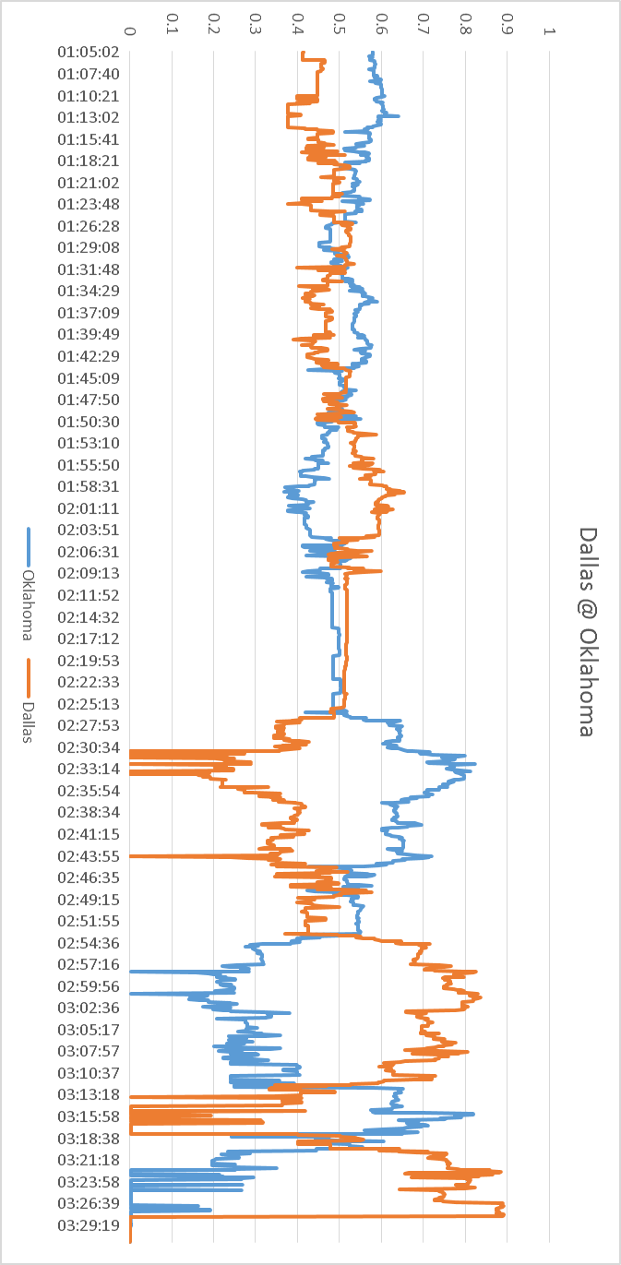

### Others

**American Football**: This sport was considered because it fit the criteria listed above well. More money was bet on American Football that British Football for an unknown reason. Possibly because of the previous existence of NFL Europe, the short season duration, growing popularity of the NFL or just less games per season, but that is all speculation. The popularity of a sport in the UK was an implicit factor that was taken into account for deciding which Sports to initially look at because there’s usually a direct correlation between popularity of British viewership for a sport and the amount bet on it, thus the amount of markets available. American Football is the exception to this rule. American Football is by far the most popular sport for viewers in the USA (SportsBusinessDaily, 2011), followed by Basketball but there’s a massive disparity between the amounts of money bet on Basketball and the amount on American Football. American Football was one of the initial main Sports considered for this project but was not attempted because the NFL season ended shortly after the data collection stage of this project started.

**Cricket:** It was initially considered as a Sport with potential for modelling but it was quickly deemed unviable. Cricket games tend to take a long time so data recording and initial analysis would be very time consuming. The main reason that cricket wasn’t modelled was that the most bet on Cricket games at the time (ICC Cricket World Cup) weren’t accessible for betting via the Betfair API for an unknown reason. The only games accessible at the time were long duration, low money wagered women’s Cricket games.

**Other Sports**: Sports that Betfair provides support for such as Golf, Horse Racing, Athletics and Motor Racing were deemed inappropriate for this project because they in at least one way failed to pass any of the specified criteria so data collection was not attempted. Most were avoided due to lack of consistent game scheduling for data collection or lack of money bet on them.

### Decision

For deciding which sport was to be modelled, how the Sport meets the defined criteria was an initial factor. The decision was primarily based upon examination of the Match Odds graph for a highly wagered upon game of the previously listed sports. The Match Odds graph was of great importance because it is displaying the probability values which will be analysed in the Predictor part of the program. Values on the graph that look more representative of the game state made it look like a more viable Sport for modelling.

Football was the selected sport to be modelled for this project. This is because when examining the Match Odds probability graph against its game report, there is a direct correlation between the changes in probability and the events of the game. This is an attractive factor because it means that a significantly less complex algorithm is required for predicting the events. It also has a constant flow of games being played which can be used for data collection and multiple games per week where millions of pounds are bet on it, providing more recent data than can be collected from other Sports.

An unconsidered factor played a major influence in the Match Odds graph, and the decision to pick a sport. The factor is the game/scoring pace. The pace of the game played a massive factor in deciding the look of the Match Odds graph. Football has a quite intuitive graph when it comes to considering what the major shifts in probability are (Goals and red cards) because of the slower pace of the game and it typically has less major events in it (Goals, red cards, yellow cards, penalties) whilst a game like basketball has constant point changes where teams can switch between winning and losing very often and quickly. The pace of the game created a much more unpredictable graph where the state of the game only really appears towards the end of the final quarter of play.

# Market Viability

As decided in the previous chapter, the topic of this project will be to create a prediction model that can predict the main events that occur in a game of Football and how they can be detected. Betfair can offer up to 94 different markets for betting which are all based around events that can happen. Only the most popular Football games have these markets available though, which limits the events that can typically be extracted and the accuracy of the predictions made. A big game with a penalties market will provide more accurate data than a smaller games but sometimes the amount of money bet doesn’t have any influence on if the event is predictable or not. Below the main events of football are detailed as well as the Betfair markets that could be used for predicting them.

The main events in football and the markets relating to them in Betfair are as follows

[See Appendix 4.1 for complete market list]

**Goals**

First, Second, xth Goal scorer, Match Odds, Runner name + x goals, Runner name to score in both halves, Runner name total goals, Both Teams to score, Correct Score, Correct Score to Home/Away, Exact total goals, First half Goals, Hat-Trick scored, Last team to score, First half Match Odds, Next goal, Over/Under x goals, Match Odds and both teams to score, Match Odds and Over/Under x goals, Odd or even, Race to x goals, Second Half Correct Score, Second Half Match Odds, To score, Total goals and Winning Margin.

**Yellow Cards**

Runner Clean Sheet, Shown a card, Bookings Match Bet, Booking Odds and Cards Over/Under x.

**Red Cards**

Runner Clean Sheet, Bookings Match Bet, Booking Odds, Cards Over/Under x, Shown a card and Sending Off.

**Fouls (in the sense of non-carded fouls)**

Penalty Taken?

**Penalties**

Penalty Taken?

**Corner Kicks**

Corner Odds, Corners Over/Under x.

**Free Kicks**

None

**First Half Over**

Match Odds, Half Time Score, First Half Goals, First Half Corners and Half Time.

**Second Half Over**

Second Half Correct Score, Second Half Goals and Second Half Match Odds.

The aim of this project is to be able to predict game events from changes in probability. In order to do this the program must be tracking at least 1 market and looking at the changes in probability. By looking at the list above it is clear that at least a few events should be possible to predict, depending on market activity. Some of the markets in the above list may not look completely relevant to the event but, as mentioned before, the changes in probability aren’t the only indication that an event has occurred. For markets such as Penalty Taken? And Sending Off the event can be decided purely by observing when the market shuts. These markets shut either when the event has occurred or when the game is over. So in order to predict events from markets like those then all that is required is to see when the market shuts and see if it’s close to when the game ends. If so then an event can be predicted.

In order to decide what events to attempt to predict, 2 factors come into place. The amount of money bet on the market during the time that it’s open (market activity) and how the probability graph for the market looks. If a market has a very small amount of money bet on it then it is immediately phased out because if there’s not enough money bet on it then there’s going to be no point considering the graph since there will be large areas where there isn’t any back/lay values so no probability can be calculated. When this occurs it makes attempting to predict pointless because there is no constant stream of information so the graphs tend to be unpredictable and would incur many false predictions since the back and lay values aren’t constantly shifting as the game changes, they jump because there is no “pre-set” odds, only what a user at an instant decides and when they decide they tend to have no information such as the last matched odds to make their decision with.

Before it is necessary to investigate the data collected, certain events can be picked with their markets already, if they are markets that close when the event occurs. At this stage the following markets have been decided to be tracked in order to predict when the events occur:

**Event - Market**

Goals - Match Odds

Red Cards - Sending Off?

First Half Over - Half Time

Second Half Over - Match Odds

The next step is to decide what other events are possible to predict by looking at the amount of money bet on them. In order to predict goals in a game, the Match Odds market will be used because, as previously shown and mentioned in the Sport Selection section, it is the most highly bet on market for all football games and it clearly shows goals in its graph. The following list details the other available events and their viability.

[see appendix 4 for supporting data]

**Yellow Cards**

Shown a Card? – Not viable. This market contains runners which are every player on both teams. ~£8000 bet on a total of 22 runners makes this unviable.

Cards Over/Under x – Not viable. Only ~£500 bet on all Over/Under markets.

Runner Clean Sheet - Not viable. Only ~£5000 bet on all clean sheet markets

Booking Odds - Not viable. Only ~£1500 bet on it.

**Fouls**

Not worth attempting. The only way that a non-carded foul can be detected is by checking to see if a penalty is scored.

**Penalties**

Penalty Taken?

**Corner Kicks**

Not viable. Approximately ~£13000 is bet on corners spread across 5 markets. So if attempted, in order to accurately predict corners all of the 5 markets need observing but with such little money bet on them then that means that there will be little activity and likely many false positives detected if attempted because implied probability values won’t be consistently collected, perhaps not ever values every minute.

**Free Kicks**

Not viable. It could somewhat be predicted by observing markets for yellow cards but yellow cards aren’t viable for predicting.

The only event on the list above that could possibly be predicted is penalties. At this stage the only markets observed for predictions are Match Odds, Red Cards and Half Time. In order to attempt to predict any of the above events the only option is to observe the markets and look for when they close (which could indicate whether or not the event occurred). The issue with that is that sometimes the markets don’t actually shut when the event occurs or they shut a significantly long time after the event occurs. Yellow Cards and Corner kicks could be attempted but would be challenging due to most likely, long durations between implied probability value calculations.

The decision was made to not record the Penalty Taken? Market because it is only typically available in more popular games. In order to attempt to get more detailed game information and validation of predictions, the follow markets will be recorded in addition to those previously mentioned: Correct Score and First Goalscorer. To summarize, the following markets will be tracked in order to predict the events that are associated with them.

Match Odds - Goals and Red Cards

First Goalscorer - First Goalscorer/verify predicted goals

Correct Score - Verify predicted goals

Sending Off? - Red Cards

Half Time - To know the time in game and be more accurate in predicting the time of events.

The following chapter will formally describe the project problem and define the specification.

# Problem Description and Specification

In this chapter a formal description of the problem will be made and a functional specification will be created. Following that, the approach to the problem will then be discussed.

### Description

As stated briefly in the introduction, the goal of this project is to pick a sport to model, create a probability model for it and attempt to predict the events in the game from the changes in probability. There exists no known program which performs this for the selected Sport so there’s a lot of possible approaches that can be taken. This will utilize the Betfair API in order to access data which will be converted into probabilities. It has to have the ability to be able to run whilst the game it’s modelling is in play and be able to predict events occurring in the game to a degree of accuracy. It needs a user facing GUI in order to display its predicted events.

### Specification

The functional requirements are formally listed below:

* **It must have a GUI**

This allows users to be able to see the predictions which the program makes and what the program believes to be the current state of the game.

It also allows users the ability to easily browse through and pick which game they want to observe.

* **It must interface in some way with the Betfair API for data**

This is an obvious functional requirement. It needs to provide an implementation which allows Betfair API methods to be called with custom parameters, which are decided by the user. It needs the ability to receive data from Betfair and then use it to calculate implied probabilities so that predictions can be made.

* **It must have a robust back end that interfaces with Betfair**

All requests to the Betfair are with JSON strings. It sends requests and expects replies back. It needs to be able to cope with the possibility that a connection may time out or no response received. It needs to be able to cope with these possibilities and keep functioning correctly.

* **It must have some algorithm implemented that is capable of predicting game events**

This requirement is vital to the project. An algorithm must be designed and implemented that has the ability to correctly predict game events shortly after they occur in the game.

* **It must model the selected game as probabilities rather than betting odds**

Again a core requirement for this project. It has to take the data that it receives from the Betfair API and convert them into probabilities which will be used to model the game and later on used for the predictor.

* **It must be able to record games and their market data**

This allows for a data set to be created and analysed in order to decide market viability and it allows the design of a successful algorithm for prediction.

The non-functional requirements to the system are listed below. The system should:

**Allow users to put in their own Betfair account credentials**

This involves a certificate file, username, password and certificate file password. This is a requirement because it allows the entire application to not to be tied an individual users account in case of password changes etc.

**Produce detailed log files for the recorded game**

By producing log files it allows all of the programs predicted and extracted probability values to be verified. It should produce files for each market in the game that is being tracked as well as individual runners probability data in the markets. It should also produce files showing actual probability data so that the produced probability can, as previously mentioned, verified. It should also produce a file showing the amount of money matched and unmatched for markets. This is so that the state of betting on the game as a whole can be observed and it can be used for further development, by knowing which markets have more reactive odds than others.

**Allow users to navigate sports and games freely before selecting a game to observe**

This is beneficial for many reasons. Firstly it means that the GUI has been designed in such a way that an individual could easily repurpose it for other Sports. It also is beneficial for extendibility. By being able to easily select other sports that means that if a prediction algorithm was implemented for another sport then minimal changes would be required to the software to implement it. It also allows the possibility of observing if an implemented predictor for a Sport has any transferable success when ran on other Sports.

**Produce test files for previously recorded games**

A requirement is to produce a file which can be used later for testing. The idea is for the program to be able to run near instantaneously on previously recorded data so that the prediction algorithm can quickly be developed and tested. Which is much better than the unfeasible alternative which is constantly running it whilst a game is in play.

**Provide a visualization of the state of the prediction values that are being manipulated behind the scenes**

This provides users with some indication of how the game state looks. It also provides a form of verification that the program is actually working, by visibly showing the state of the game. This is much more beneficial than having a single view only showing numbers which are static for most of the game, especially if it’s being run live.

**Have a test mode**

It should have a test mode where it can deviate from the typical path of logging in, selecting a sport, selecting a game etc. So that it can run completely offline on historical data. This aids development of the prediction algorithm and makes the process of testing such algorithms extremely quick.

**Perform its interactions with the API with as few method calls as possible**

By completing its interactions as quickly as possible it means that the program has the ability to query faster and it makes it usable on slow network connections. By executing quickly it allows the possibility for rapid querying to be performed so that if required, more data can be collected and the program can react faster to probability changes. It also means that more complex, slower running, prediction models could be used. If the program can execute quickly then it becomes significantly more responsive to the actual market and in turn can become more accurate, in terms of the time in game that it predicts events.

These functional and non-functional requirements were decided so that, firstly, the system successfully performs its objectives. The requirements allow the program to be quickly and efficiently tested. It has the minimal number of requests to the API so it’s suitable for execution on slower network speeds, improving its portability. By making it produce a large number of output logs it allows all of the system to be verified and it allows a lot of analysis of the game to be performed, since it provides you copies of the raw odds data, the probability data, timestamps and the amount of money bet on all of the games markets.

### Approach

The system is rather complex as a whole and it was split up into 3 different parts that communicated together. The system was broken up into a back-end data collector module, a back-end data analysis module and then the front end GUI. The first module that had to be developed was the back end data collector. In order to decide what Sport was going to be selected, what events would be predicted and what markets would be observed, it initially required a data set to be produced so that it could be analysed by hand. The data set initially had only to be of betting odds, no probabilities. After analysis of the data, the Sport was selected along with the events that the program should be able to predict, then the analysis module was developed.

The program was built in an iterative approach where each iteration build upon the previous and new features were constantly added. The majority of implementation time was spent on the back end and only near the end of the development time window was the front end added. It started as a simplistic program which simply logged into the Betfair API, requested data for hard coded parameters and outputted the results to the console. On a weekly basis more features were added and its capabilities increased.

# System Design

This chapter will build upon the system requirements listed in the previous chapter. It will detail the high level system design that was created so that the program could fulfil its functional and non-functional requirements. It will also explain the formula chosen for calculating probability.

### Calculating implied probability

This project will use a fairly simplistic approach for calculating the probability a runner has at winning its market at any point in time. It uses the assumption that Betfair users are fairly knowledgeable in the Sport that they are betting on and have some knowledge about the teams playing. By using the assumption that the users are “smart” and that the users’ use “smart” bets then that must mean all bets that are placed are all favoured in some way towards the user.

Consider the example that Manchester United are playing Arsenal. The score is 2 – 0 to Manchester United and 50 minutes have elapsed in the game. The following values are given for the runner Arsenal:

Back: 1000

Lay: 1.01

Now by using the previous assumption, it means that some users don’t think that it’s impossible for Arsenal to win. The best available Back is 1000, so if you put a £2 stake on you would get £1998 profit. This option is provided by someone who has put money down with extremely high risk but also extremely high possible profit. The user is unlikely to have put much money down but if the event occurs it’s highly beneficial to them. This is the “smart” bet by the user, low risk for possibly incredibly high profit. On the other hand someone is offering a Lay at the odds of 1.01

By using the assumption that these bets are smart and beneficial to either party offering them. By assuming that they are beneficial then we have a range of 1.01 which benefits one user to 1000 that benefits the other. We assume that these are beneficial to each party and not far from the truth. By thinking that it’s not far from the truth we calculate our probability of Arsenal winning by taking the midpoint of the values that are beneficial for polar opposite parties. We then divide 1 by the number to get a range of 0.0 (impossible) to 1.0 (unstoppable). In this case we say the probability of Arsenal winning is 1/ ((1000 + 1.01)/2) which is 0.0019. Not impossible but extremely unlikely.

This is the formula used to calculate the probabilities that are used in this project.

1 / ((Best Lay Value + Best Back Value)/ 2)

Where the best lay value is the highest available and the best back value is the lowest available.

### System breakdown

The entire system was broken down into 4 separate components. The front end GUI is the first component, it allows user interaction and its purpose is to allow users to select a game to observe and provide a graphical representation of the predicted state. The back end consists of 3 components. These are the data collector, data analysis and the predictor module. The back end was split into 3 main components because the task of getting data, parsing it and then making predicts was too large of a task to not split up. It also allows the possibility of hot swapping components out thus improving extendibility. Below is a diagram of how the components within the system will interact with one another. Afterwards there are sections which provide a detailed description of how the components meet the specification.

Probabilities

Predictions

Request

**Analysis**

**GUI**

**Collector**

**Predictor**

Probabilities

Predictions

Odds Data

**Betfair API**

Data Collector

The back-end data collector is the only part of the program which interacts with the Betfair API. It is the centralised point of entry for all Betfair data. It will query the Betfair API constantly at a pre-set time (5 seconds, 10 seconds). It will query Betfair for data regarding the selected markets for tracking, which were decided in the Market Viability chapter. It will also request data regarding all of the active markets for the game, this is for the functional requirement that produces logs. It will request odds data for the selected markets but it will also query all markets available for data regarding the amount of money bet on each market. This is because it provides useful data that can be used if the program were to be extended, such as showing the typical amount of money that other markets receive, which allows the possible identification of events that could be predicted. The collector class will take in large amounts of data in as few requests as possible. It is responsible for storing all of the data it receives in a legible format so that it can be used for results verification, testing and reference in case of future extension. Its other main role in this system is to take the raw betting data that it receives from the API (which is just a small subset of what it receives as a whole), convert it into implied probability values, using the formula from the Calculating Probability section, package it and send it to the Analysis Module.

### Data Analysis

The Analysis class acts as the man in the middle for the Collector, Predictor and GUI. Its purpose is to receive probability data from the Collector module and then feed it into the Predictor. After the Predictor receives the data and processes it, the Analysis class then takes the predictions from it. It then packages the predictions into an object and passes it to the GUI for display. It has to be able to provide special functionality when the program starts. It’s responsible for extracting useful information from the probabilities it receives in order to give the GUI data that’s required only for starting up, such as: what are the team names are, who’s playing at home and the time that the game started. The Predictor only makes predictions so it’s up to the Analysis module to get the information.

### The Predictor

An instance of the Predictor will exist for each market that is being tracked. The Predictors job is first to receive probabilities and timestamps. It first has to convert the timestamps to timestamps that are relevant for the game, for example turn 8:46:02PM to 45 + (1:02). After it converts the timestamps its job is then to make Predictions. For each runner in the market that it is observing, it will apply the algorithm (discussed in Detailed Design and Implementation) to its set of recent probabilities for each runner in the market and produce predictions. It will package the predictions up into an Object which will be accessible to the Analysis module so that it can go to the GUI.

### The GUI

The GUI is the point of entry for testing and live game observing. As a whole it will consist of 6 different views. Below is a diagram of view interaction and following that each view is briefly explained.

**Test File Locator**

**Analysis**

**Log in**

**Game Select**

**Market Select**

**Sport Select**

**Log in**

The purpose of the log in view is to allow users to log in. It will provide fields for users to enter their own Betfair account details and it allow them to select to use their own certificate file, which is required for logging into Betfair. It allows custom options to be on such as debug mode which prints all JSON requests and replies which is useful for testing. It also allows a test mode option, which when selected will allow users to transition to the Test file Locator view (without needing to actually log in). Once the user enters their account details and presses a button then this view will attempt to log them in. If unsuccessful it will inform the user of why, if successful it will then transition to the Sport select view

**Sport Select**

This view is simply for allowing the user to select which Sport they wish to see the available games for. It will provide a list of Sports available and allow the user to select one and proceed to the next view.

**Game Select**

This view receives the Sport selected from the previous view and provides users a list of all the available games to observe. It will provide users useful information such as the game name, the start time and the country that the game is being played in. Once the user selects a game and presses a button they will be transferred to the next view. It will also users to go back and select another Sport.

**Market Select**

The market select view will display all of the markets that are available for the game. This is mostly just so that the view is easily extendable. It will also provide a button which can be pressed that will select the markets that are actually supported by the program. It provides navigation buttons to proceed to the Analysis view or go back to the Game Select view.

**Test File Locator**

This view is only accessible via the login view while the test mode option has been selected. It will provide a button that allows users to select the file they want to test the program on (which is generated by observing a game start to finish). It will also show the user the location of the selected file for verification. Once the file has been selected it provides navigation buttons to go back to the Log in view or to proceed to the Analysis view for the selected game.

**Analysis**

The Analysis view is where the predicted state of the game is shown. It is split into 2 main segments, one for the general game information (Team A vs Team B, game time, start time, score) and another segment which is used to show the predictions and a provide a visual representation of the game. The idea for this view was taken from the common GUI that football manager games provide. The prediction/visual view is split into 2 separate views. The first view will have a table listing the predictions with the time that they were predicted. The visual view will be a graph which will display the runners’ probability for the most recent updates. A basic diagram of the Analysis view is shown below.

**Analysis View**

**Team 1 Game Team 2**

**details Information details**

**Analysis**



1.0

↑

0.0 Time →

**.. .. ..**

**.. .. ..**

**.. .. ..**

**Time Prediction Team**

**15’**

Goal Team 1

**… … …**

OR

0:00 Time 1:50

### Summary

This chapter has provided a high level description of the program and has described how the system will meet the specification that was previously defined. The next chapter is Detailed design and implementation which will go deeper go into the specifics of the design choices made whilst implementing the system and describe how some of the core components of the program were implemented.

# Detailed Design and Implementation

This chapter shows the design of the project at a deeper level of detail that the previous, and discusses some of the key parts of the implementation. Design choices and the 3rd party dependencies are also listed.

### Detailed system diagram

Below is a more detailed version of the system diagram shown in the previous chapter. It shows the key classes that make up each component of the system and following that, the design choices and dependencies will be mentioned and then the components will be explained in more detail.

**System Diagram**

Predictions

Probabilities

**Predictor**

**GUI**

**Analysis**

**FootballPredictionModel**

**AnalysisView**

**DataAnalysis**

Predictions

Probabilities

**GameRecorder**

**Collector**

Request

**BetFair API**

**DataIO**

**DataManager**

Odds Data

**SimpleBetfair**

**BetfairCore**

### Basic Class Diagram

A more detailed class diagram can be found in appendice x.

## Implementation Language

Java was the chosen implementation language. Initially there was a choice between implementing in either Python or Java. The benefits of Python were that it was much faster to be able to build up functionality like creating the GUI or adding new features. The code required to send requests to the Betfair API (HTTP POST) was significantly smaller and more readable than the Java alternative. The downside to Python was that the author had little experience with it and in the early stages of the project, a prototype had to be quickly made to collect data. The chosen implementation for the project was Java. This decision was primarily made because of the existence of the GSON library (see GSON section ahead). For this project, the GSON library allows the Betfair JSON replies to be serialized into Java objects. The Betfair examples provided a large set of objects that were used for GSON conversion. The Python JSON library also allows conversion of JSON to objects but every object that would be created still needed to be designed and implemented. The advantage of Java is that in Betfairs’ provided example programs they provided all of the possible objects that would be created from JSON serialization, which meant that no time would have to be spent further investigating the API to decide which objects to implement and their specifications. By using Java and the Betfair object stubs it meant that the process of collecting data was just the act of getting a response String, converting it to a list of Objects and then getting information from getter methods.

## Design Choices

### Observer vs Shared Memory

In the system there were 2 main areas that required communication between components. The first area is between Collector and Analysis. The second is between Analysis and the GUI. In order to allow communication between these areas, there were 2 solutions identified.

The first solution is Shared memory. If the shared memory solution were to be implemented then that means there needs to be some form of Collection object that both of the communicating components have a reference to. The idea is that if shared memory communication exists between the Collector and Analysis then when data is collected, the Collector would have to populate the collection with data. Whilst the Analysis module was idle it would have to be constantly querying the collection to see if any data was added, and if so it would have to take it from the collection and then process it. The issue with this is firstly is that it means all Modules are forced to run on their own threads. This is so that the memory populating module can actually populate the shared memory and the other module can be actively querying it. Another implication of this, is that the collection would need some form of synchronized method to only allow access to the shared memory by one component at a time. Otherwise there would be concurrency issues where one component is trying to populate the memory with new information whilst the other is trying to remove it.

The second solution is using the Observer design pattern which notifies by pushing data. With the Observer pattern each component would be an Observer, Observerable or both. The advantages of this are that it doesn’t force explicit multithreading. Looking at the communication between Collector and Analysis, the Observer is Analysis and the Observable module is Collector. The Collector would perform its job by querying the API, converting the data into probabilities and then notifying its Observer with the probability data.

The Observer pattern was chosen and implemented for this program. It was chosen, firstly because it allows loose coupling between the communication modules, so that if desired different implementations of them could be used with minimal changes. It also still allows freedom with how exactly the modules are implemented, using individual threads are still an option but it’s not a forced requirement.

### TimerTask vs Thread

The Collector module was responsible for querying the Betfair API at pre-defined intervals of time which means it’s only required for execution at these pre-determined intervals of time. So if it was to gather data every 5 seconds it would perform its request, store all the data it needs, convert some of it to probabilities and update its observer(s) with that data and then remain idle until the next interval. It must also stop running once it detects the ending of the game and make its Observer(s) aware of this. There were 2 identified possible solutions to get the desired behaviour.

The first solution is running the Collector on its own thread. The class in the collector responsible for activating at the times would either implement the Runnable interface or extend the Thread class. It would have to be started by a component in Analysis which is in turn started by an event in the GUI. It would then have to execute its run method every interval that was set. There are 2 ways that it could execute at the time. The first is to be told the time (e.g. 5 seconds) and it would have to have some form of loop where it executes, looks at how much time until the next time and sleep for that amount. The alternative option is to embed it inside a TimerTask object which could be scheduled with a Timer to execute every x milliseconds at a predefined starting time.

The second alternative is to use TimerTask. If TimerTask were to be used then the class that needs to collect data every interval would be a subclass of TimerTask. It would be scheduled to start executing at a time and to execute every x milliseconds. It would run until it detects that the game is over and it would stop itself and inform the Observer that it’s finished which would halt the program execution.

TimerTask sub classing was the selected solution to this issue. A TimerTask suits the needs for the Collector very well. It requires minimal additional code to schedule it to execute at the selected interval and it can be schedule to start at any time.

## Design Patterns used

### Observer

The Observer pattern is used in 2 places in the system. The first occurrence is between Analysis and Collector. The Collector is Observable and it pushes up the probability data to its Observer, Analysis. The next use is between Analysis and GUI. Analysis is the Observable object in this relationship, it uses the probability data it receives, gives it to the Predictor and then gets Results. It then notifies its Observer which is the GUI with its predictions to be displayed.

### Template

The template pattern is used in the GUI. Specifically the BetFairView superclass. It defines the order in which GUI views are created, which is set up the panels, add the menus, centre the view and then display the view.

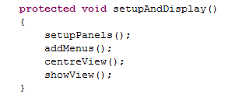

### Factory

The Factory pattern is used in the Analysis module, specifically the DataAnalysis class. The DataAnalysis class obtains the type of PredictionModel object to use depending on the EventTypeId that it receives from the GUI. This allows new PredictionModel implementing objects to be added to the system seamlessly to provide prediction support for other Sports.

## 3rd party libraries used

### JFreeChart

JFreeChart is used on the GameAnalysis view. It’s used to provide a graph of the most recent probability values for the selected games runners.

### JCOMMON

JCommon is a dependency required for JFreeChart.

### GSON

GSON is a library, developed by Google, which allows the conversion of JSON strings to Java Objects and vice versa, using Object serialization and deserialization. It is used in the Collector module of the system to convert the objects representing requests to JSON strings and to convert the JSON string responses to Objects.

### Apache HTTP Components

Apache HTTP Components was used for sending HTTP Post requests to the Betfair API for data and for receiving the responses.

## Initial System

Initially the system was built up from different sample programs and methods provided by Betfair. In order to send any requests to the Betfair API that are to be served, a session token is required. A session token is generated only when a user logs into Betfair, either interactively or non-interactively (logging in using code). Betfair provides code examples for both processes. For this project a non-interactive log in is required.

Betfair also provides code examples on GitHub which demonstrate the methods that the Betfair API supports. For Java the code base required a session token before it could run, so it had no log in support.

The first step of this project was to collect data so initially the non-interactive log in code that Betfair provided was combined with the API method demonstrating code to form the earlier version of this project. Many classes provided by the method demonstrating code were used for GSON serialization and for sending HTTP posts. These classes still exist in this project, most of them unmodified.

## Components

Below are the main Java classes that make up the key components of the system. An explanation of the function of the classes is also given.

### Collector

**GameRecorder**

GameRecorder is the class that is controls the Collector module. It is a subclass of TimerTask and it is the class that manages the various components, which are mentioned in the sections below. It contains references to the Betfair Object, DataIO object and DataIO. It is also an Observable class, which is observed by DataAnalysis. GameRecorder is the only class in Collector that gets Betfair data. It was designed to be the single point of entry because there needed to be a way of testing the program quickly. This class contains 2 different constructors, one for normal operation where it requests data from the Betfair classes. The other constructor is for testing purposes, it receives a special object (TestFile object) on initialization which it uses to get old Betfair data, which has been saved from previous game recordings. The GameRecorder activates every 5 seconds. It requests data from the Betfair classes and distributes it to the class that is tasked with storing data. It then requests formatted data from the aforementioned class and pushes it up to its observer. Figure x below shows what happens when GameRecorder runs in “live” mode.

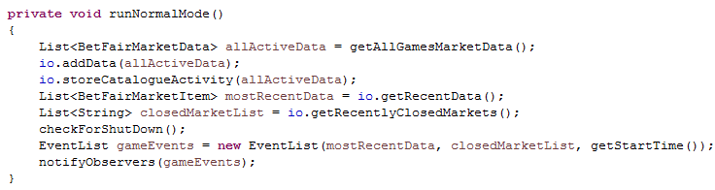

**DataIO**

The DataIO class is responsible for taking large amounts of Betfair data from the GameRecorder class and managing it. It selectively takes out information regarding the amount of money bet for markets and formats data such as the raw odds into a readable form. It stores all of that information which is later saved to log files. It also selectively filters out data regarding the markets that are being tracked and calculates probability values from it and it stores that in a dedicated Collection. It provides public methods so that the GameRecorder can extract that information. It’s also responsible for recognising when markets close so that it can stop tracking them and make the GameRecorder aware. Once all of a games tracked markets are closed it will save all of its log contents to a special folder for the game and make the GameRecorder aware that the game is over.

**DataManager**

The DataManager class is used to store general game information that’s required by the GameRecorder class and the DataIO class. As previously mentioned, Betfair requires game/market/runner ids when certain methods are called. The job of the DataManager is to store the ids and the names they match to. It stores the list of all tracked markets and the names of them. It stores this information so that in other parts of the project, if Ids need resolved to names or names to Ids then it is called. It’s also responsible for keeping track of the Collection of active markets that data is going to be requested for.

**BetfairCore/SimpleBetfair**

BetfairCore is the class that is used to send and receive requests to the Betfair API. It provides an implementation for all of the methods discussed in the Betfair chapter. It also provides an implementation for logging into Betfair which is required before any requests can be made. It heavily uses the GSON library to convert the JSON strings it receives to Objects which can be manipulated.

SimpleBetfair is a class which is composed of a BetfairCore object. It is used to simplify requests to Betfair and to simplify the results. It provides methods with more “thoughtful” names, such as getSupportSportList which calls listEventTypes. It has more meaningful names to the average person who’s unfamiliar with the Betfair API for all supported methods. It also “repackages” data that it receives from BetfairCore. The BetfairCore methods tend to receive much for information that’s actually needed for the predictions and logs so the SimpleBetfair class picks out information that’s actually required and puts it into a new object. For example on the

### Analysis

**DataAnalysis**

The DataAnalysis class is used as an intermediary class that sits between the PredictionModel, AnalysisView and GameRecorder. It observes GameRecorder and it is observed by AnalysisView. It receives updates from the GameRecorder class, containing information such as runner names, their probabilities, and timestamps. It then takes the received data, sends it to the PredictionModels (one for each market) and then requests predictions. Once it receives the predictions it then packages them into an object and send them to the AnalysisView so that they can be displayed.

### Predictor

**FootballPredictionModel**

The FootballPredictionModel class is used for making predictions. It receives sets of probabilities and timestamps for each runner in the market that it’s predicting events for. It takes each runners and adds them to its internal collections which store probability values that it received before the one that it’s currently handling. It’s also responsible for converting the timestamps to actual game time. It receives timestamps for each probability which is in the form of milliseconds from epoch time. It then converts that into the actual time in the game (1:02, 45 + 1:2 etc.) by looking at the time in relation to when the game actually started and it uses other information such as when half time ended (see chapter on market viability). Its primary job is to take the most recently probability values that it receives and add it to the internal collection it stores and apply an algorithm to it. If the algorithm detects an event then it will output the timestamp, event and what runner it is for. See below for a high level description of the algorithm.

**Prediction Algorithm**

Each PredictionModel object stores a list of the most recent prediction values that it’s received, for each runner. What happens is that every time values are added to the list, older values are popped off (if necessary) and the algorithm is applied. The implemented PredictionModel class stores the last 8 probability values it received for each runner in the Market it represents. See the diagram below for an example.

Market: Match Odds

0

1

2

3

4

5

6

7

Runner: The Draw

0

1

2

3

4

5

6

7

Runner: Team A

0

1

2

3

4

5

6

7

Runner Team B

The PredictionModel adds to the end of the list, and if the size goes over 8 then it removes the oldest element from the front. The prediction algorithm is then applied to the values in index 6 and 7. The idea to apply the algorithm to the last 2 points that were received was chosen because the only alternative considered at the time was to apply the algorithm over all of the stored points. If it were to be applied to all stored points then it there would have to be measures taken to ensure that if any point currently active in the list was being considered as an indication that an event has occurred then there needs to be some form of restriction that would make future applications of the algorithm ignore those points. The idea to apply the algorithm to the last 2 points in the collection was chosen because the only known disadvantage of it is that if a goal occurred extremely early in the game (first 50 seconds) then it could not be detected. For Football, the designed prediction model only looks for probability increases and ignores the market for the game draw. This is because typically in a game the changes in one market are reflected in the other two. So if Team A scores there is an increase in the probability that A wins whilst a decrease in the draw probability and Team Bs probability reflecting the decreased chance that the event occurs. If team B then equalizes then there’s an increase in team Bs probability as well as the draw probability whilst a decrease in Team A probability. The draw market is ignored because any goals for a team should be reflected in the scoring teams’ probability as well as the draw but the change is more dramatic in the scoring teams’ probabilities

[See Appendix 7 for examples]

The prediction algorithm works by being examining the last 2 probability values that it received. In the Appendix 7 it can be observed that when a goal is scored in a game, that there is a spike in probabilities for the goal scoring runner.

The algorithm is applied to all the data received for all tracked markets. It is broken up into 2 stages. The first stage looks for dramatic changes between the probability values in indexes 6 and 7 for all market runners. In order to accurately detect the changes in probability it treats the runner in one of two ways, depending on how likely the runner is to win. In appendix 7, the Man Utd vs Aston Villa graph shows that initially Aston Villa is significantly less likely to win than Man Utd. When a team is the underdog then when they score, no matter if it’s an equalizer or it puts them in the lead, there is a smaller increase in the probability that they win than when a favourite scores or when the game is evenly matched and one team scores. The increase in probability of winning tends to increase by at least ~0.1 for favoured teams or teams that are equally matched. Whilst underdogs probabilities can rise for a fraction of that. The two cases are required to accommodate detecting an increase in probability for the underdog or a normal team. The method of detecting probability spikes for them are as follows:

**If the value before the spike is less than 0.2 (Underdog)**

The spike value must be at least 2x more than the value before.

**If the value before the spike is greater than 0.2 (Normal/Favoured team)**

The spike value must be at least 0.075 higher than the value before.

If a spike value passes this requirement then it goes onto the final stage of the first step. False positives can occur when an implied probability value dips for a few iterations and then returns to normal. In order to not predict false events from this occurrence the following conditions must be met:

**The percentage change from: mean probability before the spike to the spike value must be greater than 5.**

And

**The percentage change from: highest probability before the spike to the spike value must also be greater than 5.**

**I**f the data meets these conditions then it goes to the second stage. The second stage of the algorithm is used to ensure that the probability spike isn’t a false positive. It is used to verify that the values after the spike are still greater than the values before. This is because a false positive can occur where there is a large probability spike that only occurs for 1 iteration, and then all values after are close to the average values before. In order to ensure that all values after the spike are closer to the spike value than the average before, the algorithm waits. It waits until there are 4 more new probabilities that are received after the spike.

Spike value

0

1

2

3

4

5

6

7

🡨OLD VALUES🡪 🡨NEW VALUES 🡪

Once the detected spike value is in the 3rd probability index then the highest probability value received after is calculated. If the highest probability value before the spike is less than the highest value received after the spike then it outputs a predicted event for the market and the runner whose value spiked, which is then given to DataAnalysis for display.

### GUI

**AnalysisView**

The AnalysisView class is used for presenting the predictions that the PredictionModel has made as well as giving the user a visual representation of the state of the game, in the form of a probability graph. It provides a frame that is split into 2 segments. The first segment contains information regarding the general state of the game (team names, who’s home, when the view was last updated, the score, the current game time). The second segment contains information about the predictions and the visual display of the game. It is a JTabbedPane with 2 tabs. The first tab shows a list of predicted events whilst the second tab shows the state of probability graph for the Match Odds market for all received data. Below is an image of the AnalysisView after a game has been simulated.

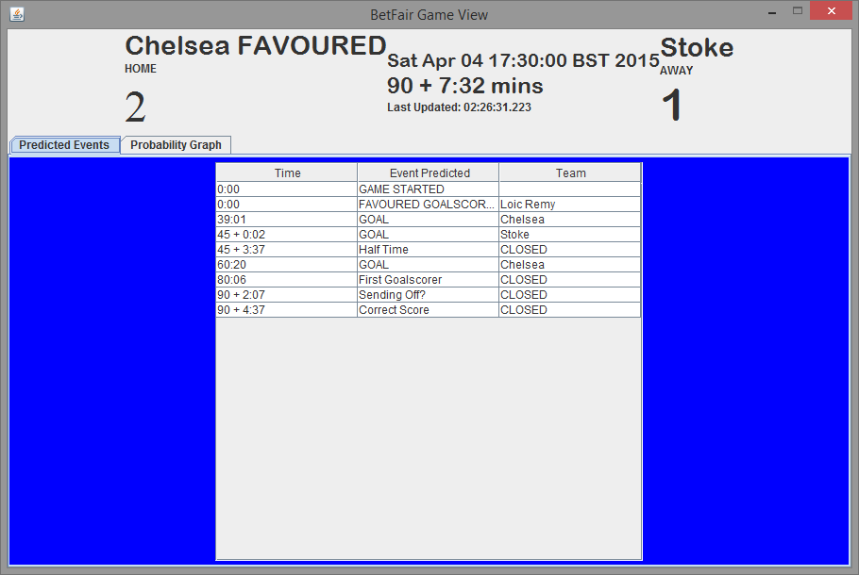

Graphical display of predicted events

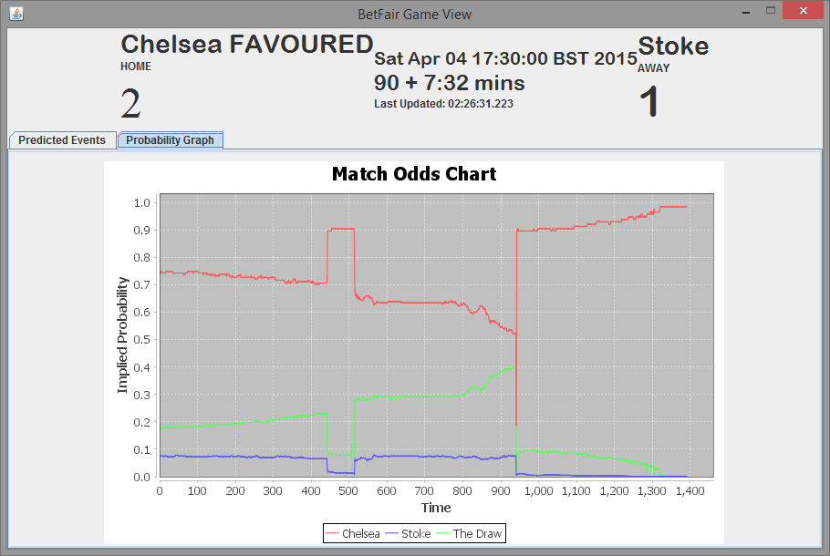

Graphical view of game state

### Implementation Issues

There were implementation issues with the DataIO and PredictionModel classes. The main issue with DataIO was that it wouldn’t correctly deal with closed markets, it would keep requesting data for markets that were closed and run forever not producing any output logs. The issues took time to reproduce and because testing functionality for simulating the program on log was only available late in the project meant it was trial and error.

The issues with PredictionModel was that because some markets and runners tend not to receive probability data very often, many false positives were produced. The false positives were produced mostly for the correct score market, which was meant to be used to validate predicted goals but instead it was predicting events like a 3-0 score line at 2 minutes into the game. Another issue with the PredictionModel is that it can sometimes output the wrong time for events due to a lack of data being received for that PredictionModel object. This is because each object has an internal store of the last time it was updated, and when markets close and produce events (e.g. sending off shuts at 63’) then it will produce an event that a player has been sent off but because it isn’t told the time that it closes it uses the last time it received data, which can be a long time ago. This produces events in the log that has timestamps that are inconsistent with the actual time the event occurs and the current game time. Another issue with the PredictionModel is that because it took longer than expected to find the weights to correctly predict events, that only goals are the produced events and they are produced only from Match Odds data. There is more code required inside the DataAnalysis class and PredictionModel class to predict Red cards and use Correct Score and First Goal scorer events with Match Odds events to produce more detailed predictions. There is also another issue with PredictionModel where it manages to produce times which appear to be the milliseconds from epoch times it takes in, rather than the converted times that are unexpected. This occurs for some of the log files given and the cause is unknown. There wasn’t enough time for a fix to be implemented.

### Summary

This chapter has provided a detailed look into the main components of the system as well as the issues encountered whilst implementing it. The following chapter details the procedures that were used for testing the program.

# Verification and Validation

Testing was performed through the project life cycle. Typically most of the program testing was performed manually and results were verified through examination of log statements and print lines. Later in the project once a format was decided for test files, the project was tested in an automated way. Automated testing occurred towards the end of the implementation process because it was required most of the back end classes to function as desired in order to produce JSON log files which were used as the basis of automated predictor testing. The following sections will detail the testing performed for the produced system.

## Black Box testing

### GUI

The GUI was tested with various use cases. The tests performed for the log in view are shown below. The tests for the rest of the views can be found in Appendix 8.

### 

|  |  |  |
| --- | --- | --- |
| **Action** | **Expected response** | **Actual response** |
| Log in with incorrect account username/password | Message box appears informing user of incorrect username or password | See expected response |
| Log in with wrong certificate password | Message box appears informing user of incorrect certificate password | See expected response |
| Log in with correct details | Log in view disappears and sport select view appears | See expected response |
| Log in with correct details and debug mode selected | Log in view disappears and sport select view appears. Request and reply string printed to console | See expected response |
| Log in with correct details and test mode selected | Log in view disappears and transition to test file select view | See expected response |
| Log in with incorrect details and test mode selected | Log in view disappears and transition to test file select view | See expected response |
| Log in with correct details but wrong certificate file selected | Message box appears informing user of incorrect certificate password | Null pointer exception. For the original file was copied and modified in a text editor so perhaps file corruption caused error. |

**As can be seen from the test results, the log in view is fairly robust.**

### Predictor/Whole System

Testing for the Predictor was performed by running the system on test files that the program has produced by observing a games and the tracked markets from start to finish. The test file contains a list of JSON objects which represent the data received from the Betfair API for every request that was performed. By ensuring that requests to the API were only called in the GameRecorder class it meant that it could run with JSON from the test file. There’s an additional constructor in the GameRecorder class which received a test file. When it receives a test file its execution deviates slightly from its usual behaviour. Every statement where it requested data from Betfair, it instead requests data from the TestFile it was given. The TestFile class simply reads a JSON line from itself, uses GSON to convert it back to the object it represented and returns it.

In order to test the Predictor it was ran on test files and the results produced were compared to the actual results, which were taken from websites with football game reports such as the BBC, Sky Sports etc. (The website used for results depends on the competition the game was played in since each of these sites tend to have a small range of games they produce reports for).

The Predictor was tested on 10 games in total. 5 of the test cases are listed below, the rest can be found in Appendix 8.

|  |  |  |  |  |  |  |  |
| --- | --- | --- | --- | --- | --- | --- | --- |
| **Game Name** | **Actual first half length** | **Predicted first half length** | **Actual second half length** | **Predicted game half length** | **Actual Score** | **Predicted Score** | **Notes** |
| Netherlands vs Spain | N/A | 36:57 | 90 + 3 | 45 + 2:41 | 2 – 0 to Netherlands  Goals at 13’ and 16’ | 2 – 0 to Netherlands  Goals at 14:26 and 17:21 | Bug causes first half length to be incorrect. Couldn’t source exact first half length |
| Italy vs England | N/A | 45 + 1:58 | 90 + 3 | 90 + 2:18 | 1 – 1  Goals at 79’ for England and 29’ for Italy | 2 – 1 to England  Goals at 29:41 to Italy and 77:55 and 90 + 1:43 to England | Extra goal predicted. |
| Chelsea vs Stoke | 45 + 2:15 | 45 + 3:37 | 90 + 4:30 | 90 + 7:32 | 2 – 1 to Chelsea  Goals at 38:03 and 61:09 to Chelsea. 43:44 goal for Stoke. | 2 – 1 to Chelsea  Goals at 39:01 and 60:20 to Chelsea. Goal at 45 + 0:02 to Stoke |  |
| Netherlands vs Turkey | N/A | 45 + 4:52 | 90 + 6 | 90 + 5:34 | 1 – 1 Draw  37’ Goal for Turkey  90 + 2 goal for Netherlands | 1 – 1 Draw  40:31 Goal for Turkey  90 + 2:39 goal for Netherlands |  |
| Everton vs Southampton | N/A | 45 + 1:19 | 90 + 3’ | 90 + 4:46 | 1 – 0 To Everton. Goal at 16’ | 1 – 0 To Everton. Goal at 15:47 | GUI view time shows 64:25 upon completion but game over event (Match Odds closing) is timed at 90 + 4:46 |

The tests show that the program can perform fairly well for the test data. There are some cases where the program produces completely wrong values for unknown reasons but other than that it can predict goals and game durations fairly accurately. The system currently can’t predict red cards because none of the games recorded actually had any. Only 1 game in the entire collection process of approx. 40 games had a red card and the game was recorded before test files could be produced.

## JUnit Testing

In the tests package in the source folder there are Junit tests. There aren’t many Junit tests because most of the program runs off JSON data extracted from the API. Since there is a large amount of dependencies on previously initialised modules for the predictor etc. it is not viable to test it via Junit.

# Results and Evaluation

In this chapter the produced system will be evaluated by comparing it against the decided specification and by evaluating how well it performs its job.

## How well it meets the specification

|  |  |  |
| --- | --- | --- |
| **Requirement** | **Functional of Non-Functional** | **Requirement met?** |
| Must have a GUI | Functional | Yes. GUI is provided for whole process of navigating sports/games/markets/showing analysis as well as logging in and locating test files. GUI is also robust |
| Must interface with Betfair API | Functional | Yes. Back end classes BetfairCore performs method calls |
| Must have robust back end | Functional | Mostly. The BetfairCore class will crash only if there is an issue when performing requests that are happening whilst data for the GUI is being retrieved. Once analysis starts it is robust and can deal with getting no responses etc. |
| Must model the selected game as probabilities (must create a game model) | Functional | Yes. Implied probability is calculated when there’s at least 1 back and lay bet for a runner, otherwise nothing is calculated and the program prevents it received no data at that time. |
| It must be able to ”record” games and their market data | Functional | Yes. Various log files are produced. See user guide for listing |
| Must have a prediction algorithm for predicting game events | Functional | Partially. It can predict goals to some accuracy and the game time. Planned events like red cards wasn’t implemented fully and validating goal predictions off Match Odds markets with predictions from other markets wasn’t implemented |
| Must allow users to use their own Betfair accounts | Non-Functional | Yes |
| Allow users to freely navigate sports and games with the GUI | Non-Functional | Yes |
| Produce test files for recorded games | Non-Functional | Yes (see record functional requirement) |
| Provide a test mode for using data from previous recordings | Non-Functional | Yes |
| Provide data visualization | Non-Functional | Yes. The Analysis view provides a list of predicted events with time stamps and team names. There’s also a graph of the probability data for all runners in the Match Odds market for the duration of the game. |
| Perform its job with the minimum number of requests | Non-Functional | Yes. There is 1 large request that’s typically broken up into a few smaller ones (due to Betfair request data limit) but that’s the only request made every update. |

As can be seen by the table above, the produced program meets all of its functional and non-functional requirements.

## Performance Analysis

Black box test results for the program can be seen in Appendix 8. The program performs quite well with the tests performed. There are some exceptional cases where the program produces completely wrong results but this doesn’t occur often (2 in 10 of the test cases produced the issue). The program produced the correct score for 50% of the test cases. Upon inspection of one of the graphs displayed by the Analysis View for the test files, the Juventus vs Empoli had a late goal which couldn’t be predicted because it occurred at 90 minutes whilst Juventus had been winning for the majority of the game, so their implied probability of winning was nearly 1.0 already. The program is also fairly accurate when it comes to predicting goal times and the half times (when they are produced), they tend to be within 1-3 minutes of the actual times.

# Conclusions

## **Success of achieving aim**

The aim of the project was to investigate sports and create a model for one or more sports and predict events. The program can successfully predict goals in football and the time that the game runs for. Technically the game times aren’t calculated by the shifting probabilities though, so it is sort of a ‘cheat’ prediction. Originally red cards were to be predicted by looking at the closing market and seeing if it related to a change in Match Odds probability but there wasn’t enough time to implement this. There also wasn’t enough time to implement verifying the goal predictions by looking at spikes in the Correct Score market. The original project plan (see Appendix 3) aimed to achieve models for multiple sports and multiple events but the creation of the back end took significantly longer than expected, as well as the creation of the predictor (mostly finding values that correctly detect probability spikes for all games) and the amount of time it took to collect data. The project does achieve its aim but not fully to the degree that was expected.

## **Problems**

Problems arose mostly in bug fixing the back end, where a bug might only become noticed once all markets shut and something crashes so no test files are produced.

There are errors that occur on some of the test files where the program stops prematurely or doesn’t produce anything close to the expected data. This errors were observed close to the project deadline and there was not enough time to fix them.

## **Future Work**

Most of the work on this project was spend implementing the back end (DataIO, DataManager) and not the Prediction classes. The program was created in such a way that large amounts of log data is produced for recorded games which could provide a basis for future work. The back end (excluding DataAnalysis and Predictor) is robust and capable of producing probabilities for any sport/game/market, except Asian Handicap where data is presented differently. Only slight modifications would be required to modify the back end to have the capacity to record multiple games at the same time which means the existing code could be repurposed to be a pure data recorder for Betfair games. The implemented Football Prediction model implements the PredictionModel interface and instances of it are obtained from a factory class, this means that anyone could come along at later time and write a PredictionModel which uses a more effective mathematic model and just plug it into the project. This also means that new PredictionModel classes could be written that are targeted towards other sports and they can be instantly added with minimal changes to the existing code. The back end is somewhat flexible by using interfaces and observer in places, so that the components that actually perform the Prediction work and tasks related to sorting events (DataAnalysis and FootballPredictionModel) could be swapped out for more effective classes.

Verification could become automated so that black-box testing the produced results isn’t required. Once Betfair markets close, after a while it is possible to find out what runner won a market so all produced events count be compared against these values e.g. is a 2-2 game result is produced then it could be instantly verified by looking to see if the 2-2 runner won the Correct Score market.

# Appendix 1 References

(ComputerWorldUk, 2012) Betfair launches ‘App Cloud’ for software developers – Computer World UK

<http://www.computerworlduk.com/news/applications/3351260/betfair-launches-app-cloud-for-software-developers/>

Last accessed 29th March 2015

(Betfair, 2014a) Annual report and accounts 2014 – Betfair

<http://corporate.betfair.com/~/media/Files/B/Betfair-Corporate/pdf/annual-report-2014.pdf>

Last accessed 2nd April 2015

(Betfair, 2014b) Betfair charges – Betfair

<http://www.betfair.com/aboutUs/Betfair.Charges/>

Last accessed 1st April 2015

(Betfair, 2015a) Betfair Historical data – Betfair

<http://data.betfair.com/>

Last accessed 2nd April 2015

(Betfair, 2015b) API’s and services – Betfair

<https://developer.betfair.com/default/api-s-and-services/>

Last accessed 2nd April 2015

(Betfair, 2015c) Getting Started with API-NG

<https://api.developer.betfair.com/services/webapps/docs/display/1smk3cen4v3lu3yomq5qye0ni/Getting+Started+with+API-NG>

Last accessed 29th March 2015

(Betfair, 2006) Sport Id list

<http://data.betfair.com/sportids.htm>

Note: The number of sports was taken from this list, minus the duplicates listed such as the Todays Card entries.

Last accessed 20th March 2015

(Ipsos-MORI, 2003) MORI Sports Tracker – Interest in Sports

<https://www.ipsos-mori.com/researchpublications/researcharchive/928/Rugby-Union-Britains-Second-Most-Popular-Sport.aspx>

Last accessed 1st March 2015

(SportsBusinessDaily, 2011) Luker on Trends & ESPN Sports Poll

<http://www.sportsbusinessdaily.com/Journal/Issues/2011/06/27/Research-and-Ratings/Up-Next.aspx>

Note: see data at bottom of page

Last accessed 2nd March 2015

(Huang 2011) Inferring Tennis Match Progress from In-Play Betting Odds

Imperial College London

<http://www.doc.ic.ac.uk/teaching/distinguished-projects/2011/x.huang.pdf>

Last accessed 2nd March 2015

# Appendix 2 Betfair API examples

**listEventTypes code example**

**Request:** {"jsonrpc":"2.0","method":"SportsAPING/v1.0/listEventTypes","id":"1","params":{"filter":{}}}

**Response:** {"jsonrpc":"2.0","result":[{"eventType":{"id":"468328","name":"Handball"},"marketCount":40},{"eventType":{"id":"1","name":"Soccer"},"marketCount":10637},{"eventType":{"id":"2","name":"Tennis"},"marketCount":691},{"eventType":{"id":"3","name":"Golf"},"marketCount":31},{"eventType":{"id":"4","name":"Cricket"},"marketCount":159},{"eventType":{"id":"5","name":"Rugby Union"},"marketCount":59},{"eventType":{"id":"6","name":"Boxing"},"marketCount":40},{"eventType":{"id":"7","name":"Horse Racing"},"marketCount":309},{"eventType":{"id":"8","name":"Motor Sport"},"marketCount":54},{"eventType":{"id":"7524","name":"Ice Hockey"},"marketCount":212},{"eventType":{"id":"10","name":"Special Bets"},"marketCount":56},{"eventType":{"id":"11","name":"Cycling"},"marketCount":9},{"eventType":{"id":"12","name":"Rowing"},"marketCount":7},{"eventType":{"id":"136332","name":"Chess"},"marketCount":10},{"eventType":{"id":"7522","name":"Basketball"},"marketCount":663},{"eventType":{"id":"1477","name":"Rugby League"},"marketCount":69},{"eventType":{"id":"606611","name":"Netball"},"marketCount":1},{"eventType":{"id":"4339","name":"Greyhound Racing"},"marketCount":151},{"eventType":{"id":"627555","name":"Badminton"},"marketCount":1},{"eventType":{"id":"2378961","name":"Politics"},"marketCount":707},{"eventType":{"id":"6231","name":"Financial Bets"},"marketCount":1},{"eventType":{"id":"998917","name":"Volleyball"},"marketCount":26},{"eventType":{"id":"998918","name":"Bowls"},"marketCount":20},{"eventType":{"id":"26420387","name":"Mixed Martial Arts"},"marketCount":33},{"eventType":{"id":"3503","name":"Darts"},"marketCount":118},{"eventType":{"id":"72382","name":"Pool"},"marketCount":1},{"eventType":{"id":"3988","name":"Athletics"},"marketCount":3},{"eventType":{"id":"2152880","name":"Gaelic Games"},"marketCount":31},{"eventType":{"id":"2593174","name":"Table Tennis"},"marketCount":1},{"eventType":{"id":"6422","name":"Snooker"},"marketCount":64},{"eventType":{"id":"6423","name":"American Football"},"marketCount":5},{"eventType":{"id":"27388198","name":"Current Affairs"},"marketCount":2},{"eventType":{"id":"315220","name":"Poker"},"marketCount":7},{"eventType":{"id":"7511","name":"Baseball"},"marketCount":9}],"id":"1"}

**listEvents JSON example (requesting all games of tennis in the given time range).**

**Request:** {"jsonrpc":"2.0","method":"SportsAPING/v1.0/listEvents","id":"1","params":{"filter":{"eventTypeIds":["2"],"marketStartTime":{"from":"2015-03-31T12:26:32.194Z","to":"2015-04-01T15:26:32.194Z"}},"sort":"FIRST_TO_START"}}

**Response:**

{"jsonrpc":"2.0","result":[{"event":{"id":"27409805","name":"Set 03","countryCode":"US","timezone":"UTC","openDate":"2015-03-31T19:00:00.000Z"},"marketCount":13},{"event":{"id":"27410105","name":"Govortsova v Foretz","countryCode":"FR","timezone":"CET","openDate":"2015-04-01T08:30:00.000Z"},"marketCount":1},{"event":{"id":"27409804","name":"Set 02","countryCode":"US","timezone":"UTC","openDate":"2015-03-31T19:00:00.000Z"},"marketCount":13},{"event":{"id":"27410106","name":"Bychkova v Linette","countryCode":"FR","timezone":"CET","openDate":"2015-04-01T08:30:00.000Z"},"marketCount":1},{"event":{"id":"27409670","name":"Buyukakcay v Mayr-Achleitner","countryCode":"US","timezone":"US/Eastern","openDate":"2015-03-31T15:30:00.000Z"},"marketCount":1},{"event":{"id":"27409671","name":"Kramperova v Larcher De Brito","countryCode":"US","timezone":"US/Eastern","openDate":"2015-03-31T15:30:00.000Z"},"marketCount":1},{"event":{"id":"27409806","name":"Isner v Raonic","countryCode":"US","timezone":"UTC","openDate":"2015-03-31T23:30:00.000Z"},"marketCount":12},{"event":{"id":"27409801","name":"G Simon v D Ferrer","countryCode":"US","timezone":"UTC","openDate":"2015-03-31T19:00:00.000Z"},"marketCount":12},{"event":{"id":"27409800","name":"Harrison/Ram v Melo/Soares","countryCode":"US","timezone":"UTC","openDate":"2015-03-31T22:15:00.000Z"},"marketCount":4},{"event":{"id":"27409803","name":"Set 01","countryCode":"US","timezone":"UTC","openDate":"2015-03-31T19:00:00.000Z"},"marketCount":13},{"event":{"id":"27409667","name":"Dominguez Lino v Glatch","countryCode":"US","timezone":"US/Eastern","openDate":"2015-03-31T17:00:00.000Z"},"marketCount":1},{"event":{"id":"27409797","name":"Set 02","countryCode":"US","timezone":"UTC","openDate":"2015-03-31T20:15:00.000Z"},"marketCount":13},{"event":{"id":"27409676","name":"Set 03","countryCode":"US","timezone":"UTC","openDate":"2015-03-31T21:00:00.000Z"},"marketCount":13},{"event":{"id":"27409796","name":"Set 01","countryCode":"US","timezone":"UTC","openDate":"2015-03-31T20:15:00.000Z"},"marketCount":13},{"event":{"id":"27409678","name":"Siegemund v Cepelova","countryCode":"US","timezone":"US/Eastern","openDate":"2015-03-31T15:30:00.000Z"},"marketCount":1},{"event":{"id":"27409798","name":"Set 03","countryCode":"US","timezone":"UTC","openDate":"2015-03-31T20:15:00.000Z"},"marketCount":13},{"event":{"id":"27409672","name":"Nishikori v Goffin","countryCode":"US","timezone":"UTC","openDate":"2015-03-31T21:00:00.000Z"},"marketCount":12},{"event":{"id":"27409674","name":"Set 01","countryCode":"US","timezone":"UTC","openDate":"2015-03-31T21:00:00.000Z"},"marketCount":13},{"event":{"id":"27409675","name":"Set 02","countryCode":"US","timezone":"UTC","openDate":"2015-03-31T21:00:00.000Z"},"marketCount":13},{"event":{"id":"27409794","name":"N Djokovic v Dolgopolov","countryCode":"US","timezone":"UTC","openDate":"2015-03-31T20:15:00.000Z"},"marketCount":12},{"event":{"id":"27408992","name":"Set 01","countryCode":"US","timezone":"UTC","openDate":"2015-03-31T14:52:00.000Z"},"marketCount":8},{"event":{"id":"27409808","name":"Set 01","countryCode":"US","timezone":"UTC","openDate":"2015-03-31T23:30:00.000Z"},"marketCount":13},{"event":{"id":"27408993","name":"Set 02","countryCode":"US","timezone":"UTC","openDate":"2015-03-31T14:52:00.000Z"},"marketCount":13},{"event":{"id":"27409809","name":"Set 02","countryCode":"US","timezone":"UTC","openDate":"2015-03-31T23:30:00.000Z"},"marketCount":13},{"event":{"id":"27408994","name":"Set 03","countryCode":"US","timezone":"UTC","openDate":"2015-03-31T14:52:00.000Z"},"marketCount":13},{"event":{"id":"27409810","name":"Set 03","countryCode":"US","timezone":"UTC","openDate":"2015-03-31T23:30:00.000Z"},"marketCount":13},{"event":{"id":"27408990","name":"A Mannarino v Thiem","countryCode":"US","timezone":"UTC","openDate":"2015-03-31T14:52:00.000Z"},"marketCount":12},{"event":{"id":"27409106","name":"Set 03","countryCode":"US","timezone":"UTC","openDate":"2015-03-31T16:35:00.000Z"},"marketCount":13},{"event":{"id":"27409104","name":"Set 01","countryCode":"US","timezone":"UTC","openDate":"2015-03-31T16:35:00.000Z"},"marketCount":13},{"event":{"id":"27408868","name":"Dushevina/MartÍnez SÁnc v Babos/Mladenovic","countryCode":"US","timezone":"UTC","openDate":"2015-03-31T16:00:00.000Z"},"marketCount":4},{"event":{"id":"27409105","name":"Set 02","countryCode":"US","timezone":"UTC","openDate":"2015-03-31T16:35:00.000Z"},"marketCount":13},{"event":{"id":"27408984","name":"H Zeballos v Londero","countryCode":"MX","timezone":"UTC","openDate":"2015-03-31T19:45:00.000Z"},"marketCount":4},{"event":{"id":"27408875","name":"Donskoy v Kudryavtsev","timezone":"UTC","openDate":"2015-04-01T08:00:00.000Z"},"marketCount":4},{"event":{"id":"27409469","name":"Cervantes v Berrer","timezone":"UTC","openDate":"2015-04-01T11:30:00.000Z"},"marketCount":4},{"event":{"id":"27409711","name":"Koolhof v Hernych","countryCode":"GP","timezone":"UTC","openDate":"2015-03-31T19:00:00.000Z"},"marketCount":4},{"event":{"id":"27409468","name":"Kravchuk v Mat Viola","timezone":"UTC","openDate":"2015-04-01T09:45:00.000Z"},"marketCount":4},{"event":{"id":"27409471","name":"Khachanov v Lacko","timezone":"UTC","openDate":"2015-04-01T08:00:00.000Z"},"marketCount":4},{"event":{"id":"27408872","name":"Kavcic v Sijsling","timezone":"UTC","openDate":"2015-04-01T09:45:00.000Z"},"marketCount":4},{"event":{"id":"27409470","name":"Arnaboldi v Ilhan","timezone":"UTC","openDate":"2015-04-01T11:30:00.000Z"},"marketCount":4},{"event":{"id":"27408980","name":"Vanni v Buchanan","countryCode":"MX","timezone":"UTC","openDate":"2015-03-31T18:00:00.000Z"},"marketCount":4},{"event":{"id":"27408978","name":"Man Sanchez v G Escobar","countryCode":"MX","timezone":"UTC","openDate":"2015-04-01T01:00:00.000Z"},"marketCount":4},{"event":{"id":"27408877","name":"Copil v Albot","timezone":"UTC","openDate":"2015-04-01T09:45:00.000Z"},"marketCount":4},{"event":{"id":"27408876","name":"Rola v Botzer","timezone":"UTC","openDate":"2015-04-01T11:30:00.000Z"},"marketCount":4},{"event":{"id":"27408976","name":"Langer v A Krajicek","countryCode":"MX","timezone":"UTC","openDate":"2015-03-31T18:00:00.000Z"},"marketCount":4},{"event":{"id":"27408882","name":"Nedovyesov v Djere","timezone":"UTC","openDate":"2015-04-01T08:00:00.000Z"},"marketCount":4},{"event":{"id":"27408880","name":"D Sela v Weintraub","timezone":"UTC","openDate":"2015-04-01T14:00:00.000Z"},"marketCount":4},{"event":{"id":"27409927","name":"Beygelzimer v Martic","countryCode":"FR","timezone":"CET","openDate":"2015-04-01T08:30:00.000Z"},"marketCount":1},{"event":{"id":"27409102","name":"J Monaco v Verdasco","countryCode":"US","timezone":"UTC","openDate":"2015-03-31T16:35:00.000Z"},"marketCount":12},{"event":{"id":"27408964","name":"Peer v Johansson","countryCode":"FR","timezone":"CET","openDate":"2015-03-31T15:00:00.000Z"},"marketCount":1},{"event":{"id":"27408542","name":"Niculescu/Panova v Hsieh/Pennetta","countryCode":"US","timezone":"UTC","openDate":"2015-03-31T19:00:00.000Z"},"marketCount":4},{"event":{"id":"27409611","name":"SuÁrez Navarro v V Williams","countryCode":"US","timezone":"UTC","openDate":"2015-03-31T22:00:00.000Z"},"marketCount":12},{"event":{"id":"27409060","name":"Berdych v Monfils","countryCode":"US","timezone":"UTC","openDate":"2015-03-31T15:10:00.000Z"},"marketCount":12},{"event":{"id":"27409063","name":"Set 02","countryCode":"US","timezone":"UTC","openDate":"2015-03-31T15:10:00.000Z"},"marketCount":13},{"event":{"id":"27409062","name":"Set 01","countryCode":"US","timezone":"UTC","openDate":"2015-03-31T15:10:00.000Z"},"marketCount":11},{"event":{"id":"27409064","name":"Set 03","countryCode":"US","timezone":"UTC","openDate":"2015-03-31T15:10:00.000Z"},"marketCount":13},{"event":{"id":"27409658","name":"Kucova v L Zhu","countryCode":"US","timezone":"US/Eastern","openDate":"2015-04-01T14:00:00.000Z"},"marketCount":1},{"event":{"id":"27409766","name":"Hingis/Mirza v Rodionova/Rodionova","countryCode":"US","timezone":"UTC","openDate":"2015-03-31T17:30:00.000Z"},"marketCount":4},{"event":{"id":"27409047","name":"Edmund v F Martin","countryCode":"GP","timezone":"UTC","openDate":"2015-03-31T19:00:00.000Z"},"marketCount":4},{"event":{"id":"27409767","name":"Petkovic v Ka Pliskova","countryCode":"US","timezone":"UTC","openDate":"2015-03-31T17:00:00.000Z"},"marketCount":12},{"event":{"id":"27409045","name":"Marie v Roger-Vasselin","countryCode":"GP","timezone":"UTC","openDate":"2015-03-31T20:45:00.000Z"},"marketCount":4},{"event":{"id":"27409663","name":"Vickery v Rodina","countryCode":"US","timezone":"US/Eastern","openDate":"2015-04-01T14:00:00.000Z"},"marketCount":1},{"event":{"id":"27409050","name":"Rochette v Calvin Hemery","countryCode":"GP","timezone":"UTC","openDate":"2015-03-31T22:30:00.000Z"},"marketCount":4},{"event":{"id":"27409048","name":"M Krueger v K De Schepper","countryCode":"GP","timezone":"UTC","openDate":"2015-03-31T20:45:00.000Z"},"marketCount":4},{"event":{"id":"27409650","name":"Ormaechea v Glushko","countryCode":"US","timezone":"US/Eastern","openDate":"2015-04-01T14:00:00.000Z"},"marketCount":1},{"event":{"id":"27409049","name":"Mahut v Bemelmans","countryCode":"GP","timezone":"UTC","openDate":"2015-03-31T19:00:00.000Z"},"marketCount":4},{"event":{"id":"27409651","name":"Kovinic v Cirstea","countryCode":"US","timezone":"US/Eastern","openDate":"2015-03-31T15:30:00.000Z"},"marketCount":1},{"event":{"id":"27409652","name":"Chirico v Mitu","countryCode":"US","timezone":"US/Eastern","openDate":"2015-03-31T17:00:00.000Z"},"marketCount":1},{"event":{"id":"27409653","name":"Rogers v Karatantcheva","countryCode":"US","timezone":"US/Eastern","openDate":"2015-04-01T14:00:00.000Z"},"marketCount":1},{"event":{"id":"27409053","name":"Gombos v Barrere","countryCode":"GP","timezone":"UTC","openDate":"2015-03-31T22:30:00.000Z"},"marketCount":4},{"event":{"id":"27409640","name":"Brengle v Krejcikova","countryCode":"US","timezone":"US/Eastern","openDate":"2015-04-01T14:00:00.000Z"},"marketCount":1},{"event":{"id":"27408898","name":"Set 01","countryCode":"US","timezone":"UTC","openDate":"2015-03-31T18:30:00.000Z"},"marketCount":13},{"event":{"id":"27409633","name":"Jorovic v Gasparyan","countryCode":"FR","timezone":"CET","openDate":"2015-03-31T12:30:00.000Z"},"marketCount":1},{"event":{"id":"27409632","name":"Melnikova v Razzano","countryCode":"FR","timezone":"CET","openDate":"2015-03-31T12:30:00.000Z"},"marketCount":1},{"event":{"id":"27408899","name":"Set 02","countryCode":"US","timezone":"UTC","openDate":"2015-03-31T18:30:00.000Z"},"marketCount":13},{"event":{"id":"27408896","name":"K Anderson v A Murray","countryCode":"US","timezone":"UTC","openDate":"2015-03-31T18:30:00.000Z"},"marketCount":12},{"event":{"id":"27409790","name":"Draganja/Kontinen v Pospisil/Sock","countryCode":"US","timezone":"UTC","openDate":"2015-03-31T20:30:00.000Z"},"marketCount":4},{"event":{"id":"27408900","name":"Set 03","countryCode":"US","timezone":"UTC","openDate":"2015-03-31T18:30:00.000Z"},"marketCount":13},{"event":{"id":"27409638","name":"Georges v Hogenkamp","countryCode":"FR","timezone":"CET","openDate":"2015-04-01T09:00:00.000Z"},"marketCount":1}],"id":"1"}

**listMarketBook JSON example. Requesting the market book for the game El Salvador vs Guatemala.**

**Request:** {"jsonrpc":"2.0","method":"SportsAPING/v1.0/listMarketCatalogue","id":"1","params":{"filter":{"eventIds":["27408709"]},"maxResults":"1000","sort":"FIRST_TO_START","marketProjection":["EVENT","EVENT_TYPE","RUNNER_METADATA","RUNNER_DESCRIPTION","MARKET_START_TIME","COMPETITION"]}}

**Response:** {"jsonrpc":"2.0","result":[{"marketId":"1.118007208","marketName":"Guatemala Win to Nil","marketStartTime":"2015-04-01T03:00:00.000Z","totalMatched":0.0,"runners":[{"selectionId":30246,"runnerName":"Yes","handicap":0.0,"sortPriority":1,"metadata":{"runnerId":"30246"}},{"selectionId":110503,"runnerName":"No","handicap":0.0,"sortPriority":2,"metadata":{"runnerId":"110503"}}],"eventType":{"id":"1","name":"Soccer"},"competition":{"id":"1985077","name":"International Friendly"},"event":{"id":"27408709","name":"El Salvador v Guatemala","countryCode":"US","timezone":"Europe/London","openDate":"2015-04-01T03:00:00.000Z"}},{"marketId":"1.118007209","marketName":"Odd or Even","marketStartTime":"2015-04-01T03:00:00.000Z","totalMatched":0.0,"runners":[{"selectionId":955466,"runnerName":"Odd","handicap":0.0,"sortPriority":1,"metadata":{"runnerId":"955466"}},{"selectionId":955467,"runnerName":"Even","handicap":0.0,"sortPriority":2,"metadata":{"runnerId":"955467"}}],"eventType":{"id":"1","name":"Soccer"},"competition":{"id":"1985077","name":"International Friendly"},"event":{"id":"27408709","name":"El Salvador v Guatemala","countryCode":"US","timezone":"Europe/London","openDate":"2015-04-01T03:00:00.000Z"}},{"marketId":"1.117992309","marketName":"Asian Handicap","marketStartTime":"2015-04-01T03:00:00.000Z","totalMatched":935.42,"runners":[{"selectionId":256609,"runnerName":"El Salvador","handicap":-4.0,"sortPriority":1},{"selectionId":440499,"runnerName":"Guatemala","handicap":4.0,"sortPriority":2},{"selectionId":256609,"runnerName":"El Salvador","handicap":-3.75,"sortPriority":3},{"selectionId":440499,"runnerName":"Guatemala","handicap":3.75,"sortPriority":4},{"selectionId":256609,"runnerName":"El Salvador","handicap":-3.5,"sortPriority":5},{"selectionId":440499,"runnerName":"Guatemala","handicap":3.5,"sortPriority":6},{"selectionId":256609,"runnerName":"El Salvador","handicap":-3.25,"sortPriority":7},{"selectionId":440499,"runnerName":"Guatemala","handicap":3.25,"sortPriority":8},{"selectionId":256609,"runnerName":"El Salvador","handicap":-3.0,"sortPriority":9},{"selectionId":440499,"runnerName":"Guatemala","handicap":3.0,"sortPriority":10},{"selectionId":256609,"runnerName":"El Salvador","handicap":-2.75,"sortPriority":11},{"selectionId":440499,"runnerName":"Guatemala","handicap":2.75,"sortPriority":12},{"selectionId":256609,"runnerName":"El Salvador","handicap":-2.5,"sortPriority":13},{"selectionId":440499,"runnerName":"Guatemala","handicap":2.5,"sortPriority":14},{"selectionId":256609,"runnerName":"El Salvador","handicap":-2.25,"sortPriority":15},{"selectionId":440499,"runnerName":"Guatemala","handicap":2.25,"sortPriority":16},{"selectionId":256609,"runnerName":"El Salvador","handicap":-2.0,"sortPriority":17},{"selectionId":440499,"runnerName":"Guatemala","handicap":2.0,"sortPriority":18},{"selectionId":256609,"runnerName":"El Salvador","handicap":-1.75,"sortPriority":19},{"selectionId":440499,"runnerName":"Guatemala","handicap":1.75,"sortPriority":20},{"selectionId":256609,"runnerName":"El Salvador","handicap":-1.5,"sortPriority":21},{"selectionId":440499,"runnerName":"Guatemala","handicap":1.5,"sortPriority":22},{"selectionId":256609,"runnerName":"El Salvador","handicap":-1.25,"sortPriority":23},{"selectionId":440499,"runnerName":"Guatemala","handicap":1.25,"sortPriority":24},{"selectionId":256609,"runnerName":"El Salvador","handicap":-1.0,"sortPriority":25},{"selectionId":440499,"runnerName":"Guatemala","handicap":1.0,"sortPriority":26},{"selectionId":256609,"runnerName":"El Salvador","handicap":-0.75,"sortPriority":27},{"selectionId":440499,"runnerName":"Guatemala","handicap":0.75,"sortPriority":28},{"selectionId":256609,"runnerName":"El Salvador","handicap":-0.5,"sortPriority":29},{"selectionId":440499,"runnerName":"Guatemala","handicap":0.5,"sortPriority":30},{"selectionId":256609,"runnerName":"El Salvador","handicap":-0.25,"sortPriority":31},{"selectionId":440499,"runnerName":"Guatemala","handicap":0.25,"sortPriority":32},{"selectionId":256609,"runnerName":"El Salvador","handicap":0.0,"sortPriority":33},{"selectionId":440499,"runnerName":"Guatemala","handicap":0.0,"sortPriority":34},{"selectionId":256609,"runnerName":"El Salvador","handicap":0.25,"sortPriority":35},{"selectionId":440499,"runnerName":"Guatemala","handicap":-0.25,"sortPriority":36},{"selectionId":256609,"runnerName":"El Salvador","handicap":0.5,"sortPriority":37},{"selectionId":440499,"runnerName":"Guatemala","handicap":-0.5,"sortPriority":38},{"selectionId":256609,"runnerName":"El Salvador","handicap":0.75,"sortPriority":39},{"selectionId":440499,"runnerName":"Guatemala","handicap":-0.75,"sortPriority":40},{"selectionId":256609,"runnerName":"El Salvador","handicap":1.0,"sortPriority":41},{"selectionId":440499,"runnerName":"Guatemala","handicap":-1.0,"sortPriority":42},{"selectionId":256609,"runnerName":"El Salvador","handicap":1.25,"sortPriority":43},{"selectionId":440499,"runnerName":"Guatemala","handicap":-1.25,"sortPriority":44},{"selectionId":256609,"runnerName":"El Salvador","handicap":1.5,"sortPriority":45},{"selectionId":440499,"runnerName":"Guatemala","handicap":-1.5,"sortPriority":46},{"selectionId":256609,"runnerName":"El Salvador","handicap":1.75,"sortPriority":47},{"selectionId":440499,"runnerName":"Guatemala","handicap":-1.75,"sortPriority":48},{"selectionId":256609,"runnerName":"El Salvador","handicap":2.0,"sortPriority":49},{"selectionId":440499,"runnerName":"Guatemala","handicap":-2.0,"sortPriority":50},{"selectionId":256609,"runnerName":"El Salvador","handicap":2.25,"sortPriority":51},{"selectionId":440499,"runnerName":"Guatemala","handicap":-2.25,"sortPriority":52},{"selectionId":256609,"runnerName":"El Salvador","handicap":2.5,"sortPriority":53},{"selectionId":440499,"runnerName":"Guatemala","handicap":-2.5,"sortPriority":54},{"selectionId":256609,"runnerName":"El Salvador","handicap":2.75,"sortPriority":55},{"selectionId":440499,"runnerName":"Guatemala","handicap":-2.75,"sortPriority":56},{"selectionId":256609,"runnerName":"El Salvador","handicap":3.0,"sortPriority":57},{"selectionId":440499,"runnerName":"Guatemala","handicap":-3.0,"sortPriority":58},{"selectionId":256609,"runnerName":"El Salvador","handicap":3.25,"sortPriority":59},{"selectionId":440499,"runnerName":"Guatemala","handicap":-3.25,"sortPriority":60},{"selectionId":256609,"runnerName":"El Salvador","handicap":3.5,"sortPriority":61},{"selectionId":440499,"runnerName":"Guatemala","handicap":-3.5,"sortPriority":62},{"selectionId":256609,"runnerName":"El Salvador","handicap":3.75,"sortPriority":63},{"selectionId":440499,"runnerName":"Guatemala","handicap":-3.75,"sortPriority":64},{"selectionId":256609,"runnerName":"El Salvador","handicap":4.0,"sortPriority":65,"metadata":{"runnerId":"256609"}},{"selectionId":440499,"runnerName":"Guatemala","handicap":-4.0,"sortPriority":66,"metadata":{"runnerId":"440499"}}],"eventType":{"id":"1","name":"Soccer"},"competition":{"id":"1985077","name":"International Friendly"},"event":{"id":"27408709","name":"El Salvador v Guatemala","countryCode":"US","timezone":"Europe/London","openDate":"2015-04-01T03:00:00.000Z"}},{"marketId":"1.118007177","marketName":"Over/Under 4.5 Goals","marketStartTime":"2015-04-01T03:00:00.000Z","totalMatched":10.82,"runners":[{"selectionId":1222347,"runnerName":"Under 4.5 Goals","handicap":0.0,"sortPriority":1,"metadata":{"runnerId":"1222347"}},{"selectionId":1222346,"runnerName":"Over 4.5 Goals","handicap":0.0,"sortPriority":2,"metadata":{"runnerId":"1222346"}}],"eventType":{"id":"1","name":"Soccer"},"competition":{"id":"1985077","name":"International Friendly"},"event":{"id":"27408709","name":"El Salvador v Guatemala","countryCode":"US","timezone":"Europe/London","openDate":"2015-04-01T03:00:00.000Z"}},{"marketId":"1.118007210","marketName":"First Half Goals 1.5","marketStartTime":"2015-04-01T03:00:00.000Z","totalMatched":0.0,"runners":[{"selectionId":1221385,"runnerName":"Under 1.5 Goals","handicap":0.0,"sortPriority":1,"metadata":{"runnerId":"1221385"}},{"selectionId":1221386,"runnerName":"Over 1.5 Goals","handicap":0.0,"sortPriority":2,"metadata":{"runnerId":"1221386"}}],"eventType":{"id":"1","name":"Soccer"},"competition":{"id":"1985077","name":"International Friendly"},"event":{"id":"27408709","name":"El Salvador v Guatemala","countryCode":"US","timezone":"Europe/London","openDate":"2015-04-01T03:00:00.000Z"}},{"marketId":"1.118007178","marketName":"First Goal Odds","marketStartTime":"2015-04-01T03:00:00.000Z","totalMatched":0.0,"runners":[{"selectionId":69843,"runnerName":"0 - 10 Minutes","handicap":0.0,"sortPriority":1,"metadata":{"runnerId":"69843"}},{"selectionId":69844,"runnerName":"11 - 20 Minutes","handicap":0.0,"sortPriority":2,"metadata":{"runnerId":"69844"}},{"selectionId":69845,"runnerName":"21 - 30 Minutes","handicap":0.0,"sortPriority":3,"metadata":{"runnerId":"69845"}},{"selectionId":69846,"runnerName":"31 - 40 Minutes","handicap":0.0,"sortPriority":4,"metadata":{"runnerId":"69846"}},{"selectionId":69847,"runnerName":"41 - 50 Minutes","handicap":0.0,"sortPriority":5,"metadata":{"runnerId":"69847"}},{"selectionId":69848,"runnerName":"51 - 60 Minutes","handicap":0.0,"sortPriority":6,"metadata":{"runnerId":"69848"}},{"selectionId":69849,"runnerName":"61 - 70 Minutes","handicap":0.0,"sortPriority":7,"metadata":{"runnerId":"69849"}},{"selectionId":69850,"runnerName":"71 - 80 Minutes","handicap":0.0,"sortPriority":8,"metadata":{"runnerId":"69850"}},{"selectionId":69851,"runnerName":"81 - Full Time","handicap":0.0,"sortPriority":9,"metadata":{"runnerId":"69851"}},{"selectionId":69852,"runnerName":"No Goal","handicap":0.0,"sortPriority":10,"metadata":{"runnerId":"69852"}}],"eventType":{"id":"1","name":"Soccer"},"competition":{"id":"1985077","name":"International Friendly"},"event":{"id":"27408709","name":"El Salvador v Guatemala","countryCode":"US","timezone":"Europe/London","openDate":"2015-04-01T03:00:00.000Z"}},{"marketId":"1.117992308","marketName":"Half Time Score","marketStartTime":"2015-04-01T03:00:00.000Z","totalMatched":0.0,"runners":[{"selectionId":1,"runnerName":"0 - 0","handicap":0.0,"sortPriority":1,"metadata":{"runnerId":"1"}},{"selectionId":3,"runnerName":"1 - 1","handicap":0.0,"sortPriority":2,"metadata":{"runnerId":"3"}},{"selectionId":7,"runnerName":"2 - 2","handicap":0.0,"sortPriority":3,"metadata":{"runnerId":"7"}},{"selectionId":2,"runnerName":"1 - 0","handicap":0.0,"sortPriority":4,"metadata":{"runnerId":"2"}},{"selectionId":5,"runnerName":"2 - 0","handicap":0.0,"sortPriority":5,"metadata":{"runnerId":"5"}},{"selectionId":6,"runnerName":"2 - 1","handicap":0.0,"sortPriority":6,"metadata":{"runnerId":"6"}},{"selectionId":4,"runnerName":"0 - 1","handicap":0.0,"sortPriority":7,"metadata":{"runnerId":"4"}},{"selectionId":9,"runnerName":"0 - 2","handicap":0.0,"sortPriority":8,"metadata":{"runnerId":"9"}},{"selectionId":8,"runnerName":"1 - 2","handicap":0.0,"sortPriority":9,"metadata":{"runnerId":"8"}},{"selectionId":4506345,"runnerName":"Any Unquoted ","handicap":0.0,"sortPriority":10,"metadata":{"runnerId":"4506345"}}],"eventType":{"id":"1","name":"Soccer"},"competition":{"id":"1985077","name":"International Friendly"},"event":{"id":"27408709","name":"El Salvador v Guatemala","countryCode":"US","timezone":"Europe/London","openDate":"2015-04-01T03:00:00.000Z"}},{"marketId":"1.118007211","marketName":"Over/Under 0.5 Goals","marketStartTime":"2015-04-01T03:00:00.000Z","totalMatched":0.0,"runners":[{"selectionId":5851482,"runnerName":"Under 0.5 Goals","handicap":0.0,"sortPriority":1,"metadata":{"runnerId":"5851482"}},{"selectionId":5851483,"runnerName":"Over 0.5 Goals","handicap":0.0,"sortPriority":2,"metadata":{"runnerId":"5851483"}}],"eventType":{"id":"1","name":"Soccer"},"competition":{"id":"1985077","name":"International Friendly"},"event":{"id":"27408709","name":"El Salvador v Guatemala","countryCode":"US","timezone":"Europe/London","openDate":"2015-04-01T03:00:00.000Z"}},{"marketId":"1.118007175","marketName":"Over/Under 1.5 Goals","marketStartTime":"2015-04-01T03:00:00.000Z","totalMatched":4.07,"runners":[{"selectionId":1221385,"runnerName":"Under 1.5 Goals","handicap":0.0,"sortPriority":1,"metadata":{"runnerId":"1221385"}},{"selectionId":1221386,"runnerName":"Over 1.5 Goals","handicap":0.0,"sortPriority":2,"metadata":{"runnerId":"1221386"}}],"eventType":{"id":"1","name":"Soccer"},"competition":{"id":"1985077","name":"International Friendly"},"event":{"id":"27408709","name":"El Salvador v Guatemala","countryCode":"US","timezone":"Europe/London","openDate":"2015-04-01T03:00:00.000Z"}},{"marketId":"1.118007212","marketName":"Over/Under 7.5 Goals","marketStartTime":"2015-04-01T03:00:00.000Z","totalMatched":4.98,"runners":[{"selectionId":1485572,"runnerName":"Under 7.5 Goals","handicap":0.0,"sortPriority":1,"metadata":{"runnerId":"1485572"}},{"selectionId":1485573,"runnerName":"Over 7.5 Goals","handicap":0.0,"sortPriority":2,"metadata":{"runnerId":"1485573"}}],"eventType":{"id":"1","name":"Soccer"},"competition":{"id":"1985077","name":"International Friendly"},"event":{"id":"27408709","name":"El Salvador v Guatemala","countryCode":"US","timezone":"Europe/London","openDate":"2015-04-01T03:00:00.000Z"}},{"marketId":"1.118007176","marketName":"Over/Under 3.5 Goals","marketStartTime":"2015-04-01T03:00:00.000Z","totalMatched":5.4,"runners":[{"selectionId":1222344,"runnerName":"Under 3.5 Goals","handicap":0.0,"sortPriority":1,"metadata":{"runnerId":"1222344"}},{"selectionId":1222345,"runnerName":"Over 3.5 Goals","handicap":0.0,"sortPriority":2,"metadata":{"runnerId":"1222345"}}],"eventType":{"id":"1","name":"Soccer"},"competition":{"id":"1985077","name":"International Friendly"},"event":{"id":"27408709","name":"El Salvador v Guatemala","countryCode":"US","timezone":"Europe/London","openDate":"2015-04-01T03:00:00.000Z"}},{"marketId":"1.118007213","marketName":"Over/Under 8.5 Goals","marketStartTime":"2015-04-01T03:00:00.000Z","totalMatched":0.0,"runners":[{"selectionId":2407528,"runnerName":"Under 8.5 Goals","handicap":0.0,"sortPriority":1,"metadata":{"runnerId":"2407528"}},{"selectionId":2407529,"runnerName":"Over 8.5 Goals","handicap":0.0,"sortPriority":2,"metadata":{"runnerId":"2407529"}}],"eventType":{"id":"1","name":"Soccer"},"competition":{"id":"1985077","name":"International Friendly"},"event":{"id":"27408709","name":"El Salvador v Guatemala","countryCode":"US","timezone":"Europe/London","openDate":"2015-04-01T03:00:00.000Z"}},{"marketId":"1.118007181","marketName":"El Salvador Clean Sheet?","marketStartTime":"2015-04-01T03:00:00.000Z","totalMatched":0.0,"runners":[{"selectionId":30246,"runnerName":"Yes","handicap":0.0,"sortPriority":1,"metadata":{"runnerId":"30246"}},{"selectionId":110503,"runnerName":"No","handicap":0.0,"sortPriority":2,"metadata":{"runnerId":"110503"}}],"eventType":{"id":"1","name":"Soccer"},"competition":{"id":"1985077","name":"International Friendly"},"event":{"id":"27408709","name":"El Salvador v Guatemala","countryCode":"US","timezone":"Europe/London","openDate":"2015-04-01T03:00:00.000Z"}},{"marketId":"1.118007214","marketName":"Correct Score 2 Home","marketStartTime":"2015-04-01T03:00:00.000Z","totalMatched":0.0,"runners":[{"selectionId":526007,"runnerName":"4 - 0","handicap":0.0,"sortPriority":1,"metadata":{"runnerId":"526007"}},{"selectionId":526012,"runnerName":"4 - 1","handicap":0.0,"sortPriority":2,"metadata":{"runnerId":"526012"}},{"selectionId":2795147,"runnerName":"4 - 2","handicap":0.0,"sortPriority":3,"metadata":{"runnerId":"2795147"}},{"selectionId":526008,"runnerName":"5 - 0","handicap":0.0,"sortPriority":4,"metadata":{"runnerId":"526008"}},{"selectionId":526013,"runnerName":"5 - 1","handicap":0.0,"sortPriority":5,"metadata":{"runnerId":"526013"}},{"selectionId":3647906,"runnerName":"5 - 2","handicap":0.0,"sortPriority":6,"metadata":{"runnerId":"3647906"}},{"selectionId":526009,"runnerName":"6 - 0","handicap":0.0,"sortPriority":7,"metadata":{"runnerId":"526009"}},{"selectionId":526014,"runnerName":"6 - 1","handicap":0.0,"sortPriority":8,"metadata":{"runnerId":"526014"}},{"selectionId":3647907,"runnerName":"6 - 2","handicap":0.0,"sortPriority":9,"metadata":{"runnerId":"3647907"}},{"selectionId":526010,"runnerName":"7 - 0","handicap":0.0,"sortPriority":10,"metadata":{"runnerId":"526010"}},{"selectionId":526015,"runnerName":"7 - 1","handicap":0.0,"sortPriority":11,"metadata":{"runnerId":"526015"}},{"selectionId":3647908,"runnerName":"7 - 2","handicap":0.0,"sortPriority":12,"metadata":{"runnerId":"3647908"}},{"selectionId":4316861,"runnerName":"Any unquoted","handicap":0.0,"sortPriority":13,"metadata":{"runnerId":"4316861"}}],"eventType":{"id":"1","name":"Soccer"},"competition":{"id":"1985077","name":"International Friendly"},"event":{"id":"27408709","name":"El Salvador v Guatemala","countryCode":"US","timezone":"Europe/London","openDate":"2015-04-01T03:00:00.000Z"}},{"marketId":"1.118007182","marketName":"Guatemala Clean Sheet?","marketStartTime":"2015-04-01T03:00:00.000Z","totalMatched":0.0,"runners":[{"selectionId":30246,"runnerName":"Yes","handicap":0.0,"sortPriority":1,"metadata":{"runnerId":"30246"}},{"selectionId":110503,"runnerName":"No","handicap":0.0,"sortPriority":2,"metadata":{"runnerId":"110503"}}],"eventType":{"id":"1","name":"Soccer"},"competition":{"id":"1985077","name":"International Friendly"},"event":{"id":"27408709","name":"El Salvador v Guatemala","countryCode":"US","timezone":"Europe/London","openDate":"2015-04-01T03:00:00.000Z"}},{"marketId":"1.118007215","marketName":"Correct Score 2 Away","marketStartTime":"2015-04-01T03:00:00.000Z","totalMatched":0.0,"runners":[{"selectionId":2795143,"runnerName":"0 - 4","handicap":0.0,"sortPriority":1,"metadata":{"runnerId":"2795143"}},{"selectionId":2795144,"runnerName":"1 - 4","handicap":0.0,"sortPriority":2,"metadata":{"runnerId":"2795144"}},{"selectionId":2795145,"runnerName":"2 - 4","handicap":0.0,"sortPriority":3,"metadata":{"runnerId":"2795145"}},{"selectionId":3316811,"runnerName":"0 - 5","handicap":0.0,"sortPriority":4,"metadata":{"runnerId":"3316811"}},{"selectionId":3316814,"runnerName":"1 - 5","handicap":0.0,"sortPriority":5,"metadata":{"runnerId":"3316814"}},{"selectionId":3694886,"runnerName":"2 - 5","handicap":0.0,"sortPriority":6,"metadata":{"runnerId":"3694886"}},{"selectionId":3316812,"runnerName":"0 - 6","handicap":0.0,"sortPriority":7,"metadata":{"runnerId":"3316812"}},{"selectionId":3316815,"runnerName":"1 - 6","handicap":0.0,"sortPriority":8,"metadata":{"runnerId":"3316815"}},{"selectionId":3694887,"runnerName":"2 - 6","handicap":0.0,"sortPriority":9,"metadata":{"runnerId":"3694887"}},{"selectionId":3316813,"runnerName":"0 - 7","handicap":0.0,"sortPriority":10,"metadata":{"runnerId":"3316813"}},{"selectionId":3316816,"runnerName":"1 - 7","handicap":0.0,"sortPriority":11,"metadata":{"runnerId":"3316816"}},{"selectionId":3694888,"runnerName":"2 - 7","handicap":0.0,"sortPriority":12,"metadata":{"runnerId":"3694888"}},{"selectionId":4316861,"runnerName":"Any unquoted","handicap":0.0,"sortPriority":13,"metadata":{"runnerId":"4316861"}}],"eventType":{"id":"1","name":"Soccer"},"competition":{"id":"1985077","name":"International Friendly"},"event":{"id":"27408709","name":"El Salvador v Guatemala","countryCode":"US","timezone":"Europe/London","openDate":"2015-04-01T03:00:00.000Z"}},{"marketId":"1.118007179","marketName":"Next Goal","marketStartTime":"2015-04-01T03:00:00.000Z","totalMatched":0.0,"runners":[{"selectionId":256609,"runnerName":"El Salvador","handicap":0.0,"sortPriority":1,"metadata":{"runnerId":"256609"}},{"selectionId":440499,"runnerName":"Guatemala","handicap":0.0,"sortPriority":2,"metadata":{"runnerId":"440499"}},{"selectionId":69852,"runnerName":"No Goal","handicap":0.0,"sortPriority":3,"metadata":{"runnerId":"69852"}}],"eventType":{"id":"1","name":"Soccer"},"competition":{"id":"1985077","name":"International Friendly"},"event":{"id":"27408709","name":"El Salvador v Guatemala","countryCode":"US","timezone":"Europe/London","openDate":"2015-04-01T03:00:00.000Z"}},{"marketId":"1.118007216","marketName":"Double Chance ","marketStartTime":"2015-04-01T03:00:00.000Z","totalMatched":0.0,"runners":[{"selectionId":6384646,"runnerName":"Home or Draw","handicap":0.0,"sortPriority":1,"metadata":{"runnerId":"6384646"}},{"selectionId":6384647,"runnerName":"Draw or Away","handicap":0.0,"sortPriority":2,"metadata":{"runnerId":"6384647"}},{"selectionId":6384648,"runnerName":"Home or Away","handicap":0.0,"sortPriority":3,"metadata":{"runnerId":"6384648"}}],"eventType":{"id":"1","name":"Soccer"},"competition":{"id":"1985077","name":"International Friendly"},"event":{"id":"27408709","name":"El Salvador v Guatemala","countryCode":"US","timezone":"Europe/London","openDate":"2015-04-01T03:00:00.000Z"}},{"marketId":"1.118007180","marketName":"Sending Off?","marketStartTime":"2015-04-01T03:00:00.000Z","totalMatched":0.0,"runners":[{"selectionId":30246,"runnerName":"Yes","handicap":0.0,"sortPriority":1,"metadata":{"runnerId":"30246"}},{"selectionId":110503,"runnerName":"No","handicap":0.0,"sortPriority":2,"metadata":{"runnerId":"110503"}}],"eventType":{"id":"1","name":"Soccer"},"competition":{"id":"1985077","name":"International Friendly"},"event":{"id":"27408709","name":"El Salvador v Guatemala","countryCode":"US","timezone":"Europe/London","openDate":"2015-04-01T03:00:00.000Z"}},{"marketId":"1.117992305","marketName":"Correct Score","marketStartTime":"2015-04-01T03:00:00.000Z","totalMatched":0.0,"runners":[{"selectionId":1,"runnerName":"0 - 0","handicap":0.0,"sortPriority":1,"metadata":{"runnerId":"1"}},{"selectionId":4,"runnerName":"0 - 1","handicap":0.0,"sortPriority":2,"metadata":{"runnerId":"4"}},{"selectionId":9,"runnerName":"0 - 2","handicap":0.0,"sortPriority":3,"metadata":{"runnerId":"9"}},{"selectionId":16,"runnerName":"0 - 3","handicap":0.0,"sortPriority":4,"metadata":{"runnerId":"16"}},{"selectionId":2,"runnerName":"1 - 0","handicap":0.0,"sortPriority":5,"metadata":{"runnerId":"2"}},{"selectionId":3,"runnerName":"1 - 1","handicap":0.0,"sortPriority":6,"metadata":{"runnerId":"3"}},{"selectionId":8,"runnerName":"1 - 2","handicap":0.0,"sortPriority":7,"metadata":{"runnerId":"8"}},{"selectionId":15,"runnerName":"1 - 3","handicap":0.0,"sortPriority":8,"metadata":{"runnerId":"15"}},{"selectionId":5,"runnerName":"2 - 0","handicap":0.0,"sortPriority":9,"metadata":{"runnerId":"5"}},{"selectionId":6,"runnerName":"2 - 1","handicap":0.0,"sortPriority":10,"metadata":{"runnerId":"6"}},{"selectionId":7,"runnerName":"2 - 2","handicap":0.0,"sortPriority":11,"metadata":{"runnerId":"7"}},{"selectionId":14,"runnerName":"2 - 3","handicap":0.0,"sortPriority":12,"metadata":{"runnerId":"14"}},{"selectionId":10,"runnerName":"3 - 0","handicap":0.0,"sortPriority":13,"metadata":{"runnerId":"10"}},{"selectionId":11,"runnerName":"3 - 1","handicap":0.0,"sortPriority":14,"metadata":{"runnerId":"11"}},{"selectionId":12,"runnerName":"3 - 2","handicap":0.0,"sortPriority":15,"metadata":{"runnerId":"12"}},{"selectionId":13,"runnerName":"3 - 3","handicap":0.0,"sortPriority":16,"metadata":{"runnerId":"13"}},{"selectionId":9063254,"runnerName":"Any Other Home Win","handicap":0.0,"sortPriority":17,"metadata":{"runnerId":"9063254"}},{"selectionId":9063255,"runnerName":"Any Other Away Win","handicap":0.0,"sortPriority":18,"metadata":{"runnerId":"9063255"}},{"selectionId":9063256,"runnerName":"Any Other Draw","handicap":0.0,"sortPriority":19,"metadata":{"runnerId":"9063256"}}],"eventType":{"id":"1","name":"Soccer"},"competition":{"id":"1985077","name":"International Friendly"},"event":{"id":"27408709","name":"El Salvador v Guatemala","countryCode":"US","timezone":"Europe/London","openDate":"2015-04-01T03:00:00.000Z"}},{"marketId":"1.117992304","marketName":"Half Time","marketStartTime":"2015-04-01T03:00:00.000Z","totalMatched":0.0,"runners":[{"selectionId":3388433,"runnerName":"El Salvador (HT)","handicap":0.0,"sortPriority":1,"metadata":{"runnerId":"3388433"}},{"selectionId":2181492,"runnerName":"Guatemala (HT)","handicap":0.0,"sortPriority":2,"metadata":{"runnerId":"2181492"}},{"selectionId":2004841,"runnerName":"The Draw (HT)","handicap":0.0,"sortPriority":3,"metadata":{"runnerId":"2004841"}}],"eventType":{"id":"1","name":"Soccer"},"competition":{"id":"1985077","name":"International Friendly"},"event":{"id":"27408709","name":"El Salvador v Guatemala","countryCode":"US","timezone":"Europe/London","openDate":"2015-04-01T03:00:00.000Z"}},{"marketId":"1.117992303","marketName":"Over/Under 2.5 Goals","marketStartTime":"2015-04-01T03:00:00.000Z","totalMatched":5.42,"runners":[{"selectionId":47972,"runnerName":"Under 2.5 Goals","handicap":0.0,"sortPriority":1,"metadata":{"runnerId":"47972"}},{"selectionId":47973,"runnerName":"Over 2.5 Goals","handicap":0.0,"sortPriority":2,"metadata":{"runnerId":"47973"}}],"eventType":{"id":"1","name":"Soccer"},"competition":{"id":"1985077","name":"International Friendly"},"event":{"id":"27408709","name":"El Salvador v Guatemala","countryCode":"US","timezone":"Europe/London","openDate":"2015-04-01T03:00:00.000Z"}},{"marketId":"1.117992307","marketName":"Match Odds","marketStartTime":"2015-04-01T03:00:00.000Z","totalMatched":85.73,"runners":[{"selectionId":256609,"runnerName":"El Salvador","handicap":0.0,"sortPriority":1,"metadata":{"runnerId":"256609"}},{"selectionId":440499,"runnerName":"Guatemala","handicap":0.0,"sortPriority":2,"metadata":{"runnerId":"440499"}},{"selectionId":58805,"runnerName":"The Draw","handicap":0.0,"sortPriority":3,"metadata":{"runnerId":"58805"}}],"eventType":{"id":"1","name":"Soccer"},"competition":{"id":"1985077","name":"International Friendly"},"event":{"id":"27408709","name":"El Salvador v Guatemala","countryCode":"US","timezone":"Europe/London","openDate":"2015-04-01T03:00:00.000Z"}},{"marketId":"1.117992306","marketName":"Half Time/Full Time","marketStartTime":"2015-04-01T03:00:00.000Z","totalMatched":125.04,"runners":[{"selectionId":2277671,"runnerName":"El Salvador/El Salvador","handicap":0.0,"sortPriority":1,"metadata":{"runnerId":"2277671"}},{"selectionId":2277670,"runnerName":"El Salvador/Draw","handicap":0.0,"sortPriority":2,"metadata":{"runnerId":"2277670"}},{"selectionId":4553543,"runnerName":"El Salvador/Guatemala","handicap":0.0,"sortPriority":3,"metadata":{"runnerId":"4553543"}},{"selectionId":2277669,"runnerName":"Draw/El Salvador","handicap":0.0,"sortPriority":4,"metadata":{"runnerId":"2277669"}},{"selectionId":3710152,"runnerName":"Draw/Draw","handicap":0.0,"sortPriority":5,"metadata":{"runnerId":"3710152"}},{"selectionId":1100527,"runnerName":"Draw/Guatemala","handicap":0.0,"sortPriority":6,"metadata":{"runnerId":"1100527"}},{"selectionId":4553544,"runnerName":"Guatemala/El Salvador","handicap":0.0,"sortPriority":7,"metadata":{"runnerId":"4553544"}},{"selectionId":1100529,"runnerName":"Guatemala/Draw","handicap":0.0,"sortPriority":8,"metadata":{"runnerId":"1100529"}},{"selectionId":1100530,"runnerName":"Guatemala/Guatemala","handicap":0.0,"sortPriority":9,"metadata":{"runnerId":"1100530"}}],"eventType":{"id":"1","name":"Soccer"},"competition":{"id":"1985077","name":"International Friendly"},"event":{"id":"27408709","name":"El Salvador v Guatemala","countryCode":"US","timezone":"Europe/London","openDate":"2015-04-01T03:00:00.000Z"}},{"marketId":"1.118007207","marketName":"El Salvador Win to Nil","marketStartTime":"2015-04-01T03:00:00.000Z","totalMatched":0.0,"runners":[{"selectionId":30246,"runnerName":"Yes","handicap":0.0,"sortPriority":1,"metadata":{"runnerId":"30246"}},{"selectionId":110503,"runnerName":"No","handicap":0.0,"sortPriority":2,"metadata":{"runnerId":"110503"}}],"eventType":{"id":"1","name":"Soccer"},"competition":{"id":"1985077","name":"International Friendly"},"event":{"id":"27408709","name":"El Salvador v Guatemala","countryCode":"US","timezone":"Europe/London","openDate":"2015-04-01T03:00:00.000Z"}},{"marketId":"1.118007191","marketName":"El Salvador Total Goals","marketStartTime":"2015-04-01T03:00:00.000Z","totalMatched":0.0,"runners":[{"selectionId":285469,"runnerName":"1 goals or more","handicap":-1.0,"sortPriority":1,"metadata":{"runnerId":"285469"}},{"selectionId":285470,"runnerName":"2 goals or more","handicap":-2.0,"sortPriority":2,"metadata":{"runnerId":"285470"}},{"selectionId":285471,"runnerName":"3 goals or more","handicap":-3.0,"sortPriority":3,"metadata":{"runnerId":"285471"}},{"selectionId":2795170,"runnerName":"4 goals or more","handicap":-4.0,"sortPriority":4,"metadata":{"runnerId":"2795170"}},{"selectionId":285473,"runnerName":"5 goals or more","handicap":-5.0,"sortPriority":5,"metadata":{"runnerId":"285473"}},{"selectionId":285474,"runnerName":"6 goals or more","handicap":-6.0,"sortPriority":6,"metadata":{"runnerId":"285474"}},{"selectionId":8215951,"runnerName":"7 goals or more","handicap":-7.0,"sortPriority":7,"metadata":{"runnerId":"8215951"}}],"eventType":{"id":"1","name":"Soccer"},"competition":{"id":"1985077","name":"International Friendly"},"event":{"id":"27408709","name":"El Salvador v Guatemala","countryCode":"US","timezone":"Europe/London","openDate":"2015-04-01T03:00:00.000Z"}},{"marketId":"1.118007219","marketName":"First Half Goals 0.5","marketStartTime":"2015-04-01T03:00:00.000Z","totalMatched":0.0,"runners":[{"selectionId":5851482,"runnerName":"Under 0.5 Goals","handicap":0.0,"sortPriority":1,"metadata":{"runnerId":"5851482"}},{"selectionId":5851483,"runnerName":"Over 0.5 Goals","handicap":0.0,"sortPriority":2,"metadata":{"runnerId":"5851483"}}],"eventType":{"id":"1","name":"Soccer"},"competition":{"id":"1985077","name":"International Friendly"},"event":{"id":"27408709","name":"El Salvador v Guatemala","countryCode":"US","timezone":"Europe/London","openDate":"2015-04-01T03:00:00.000Z"}},{"marketId":"1.117992295","marketName":"Total Goals","marketStartTime":"2015-04-01T03:00:00.000Z","totalMatched":0.0,"runners":[{"selectionId":285469,"runnerName":"1 goals or more","handicap":-1.0,"sortPriority":1,"metadata":{"runnerId":"285469"}},{"selectionId":285470,"runnerName":"2 goals or more","handicap":-2.0,"sortPriority":2,"metadata":{"runnerId":"285470"}},{"selectionId":285471,"runnerName":"3 goals or more","handicap":-3.0,"sortPriority":3,"metadata":{"runnerId":"285471"}},{"selectionId":2795170,"runnerName":"4 goals or more","handicap":-4.0,"sortPriority":4,"metadata":{"runnerId":"2795170"}},{"selectionId":285473,"runnerName":"5 goals or more","handicap":-5.0,"sortPriority":5,"metadata":{"runnerId":"285473"}},{"selectionId":285474,"runnerName":"6 goals or more","handicap":-6.0,"sortPriority":6,"metadata":{"runnerId":"285474"}},{"selectionId":8215951,"runnerName":"7 goals or more","handicap":-7.0,"sortPriority":7,"metadata":{"runnerId":"8215951"}}],"eventType":{"id":"1","name":"Soccer"},"competition":{"id":"1985077","name":"International Friendly"},"event":{"id":"27408709","name":"El Salvador v Guatemala","countryCode":"US","timezone":"Europe/London","openDate":"2015-04-01T03:00:00.000Z"}},{"marketId":"1.118007220","marketName":"First Half Goals 2.5","marketStartTime":"2015-04-01T03:00:00.000Z","totalMatched":0.0,"runners":[{"selectionId":47972,"runnerName":"Under 2.5 Goals","handicap":0.0,"sortPriority":1,"metadata":{"runnerId":"47972"}},{"selectionId":47973,"runnerName":"Over 2.5 Goals","handicap":0.0,"sortPriority":2,"metadata":{"runnerId":"47973"}}],"eventType":{"id":"1","name":"Soccer"},"competition":{"id":"1985077","name":"International Friendly"},"event":{"id":"27408709","name":"El Salvador v Guatemala","countryCode":"US","timezone":"Europe/London","openDate":"2015-04-01T03:00:00.000Z"}},{"marketId":"1.118007217","marketName":"El Salvador +1","marketStartTime":"2015-04-01T03:00:00.000Z","totalMatched":0.0,"runners":[{"selectionId":6973035,"runnerName":"El Salvador +1","handicap":0.0,"sortPriority":1,"metadata":{"runnerId":"6973035"}},{"selectionId":6973032,"runnerName":"Guatemala -1","handicap":0.0,"sortPriority":2,"metadata":{"runnerId":"6973032"}},{"selectionId":151478,"runnerName":"Draw","handicap":0.0,"sortPriority":3,"metadata":{"runnerId":"151478"}}],"eventType":{"id":"1","name":"Soccer"},"competition":{"id":"1985077","name":"International Friendly"},"event":{"id":"27408709","name":"El Salvador v Guatemala","countryCode":"US","timezone":"Europe/London","openDate":"2015-04-01T03:00:00.000Z"}},{"marketId":"1.118007199","marketName":"Guatemala Total Goals","marketStartTime":"2015-04-01T03:00:00.000Z","totalMatched":0.0,"runners":[{"selectionId":285469,"runnerName":"1 goals or more","handicap":-1.0,"sortPriority":1,"metadata":{"runnerId":"285469"}},{"selectionId":285470,"runnerName":"2 goals or more","handicap":-2.0,"sortPriority":2,"metadata":{"runnerId":"285470"}},{"selectionId":285471,"runnerName":"3 goals or more","handicap":-3.0,"sortPriority":3,"metadata":{"runnerId":"285471"}},{"selectionId":2795170,"runnerName":"4 goals or more","handicap":-4.0,"sortPriority":4,"metadata":{"runnerId":"2795170"}},{"selectionId":285473,"runnerName":"5 goals or more","handicap":-5.0,"sortPriority":5,"metadata":{"runnerId":"285473"}},{"selectionId":285474,"runnerName":"6 goals or more","handicap":-6.0,"sortPriority":6,"metadata":{"runnerId":"285474"}},{"selectionId":8215951,"runnerName":"7 goals or more","handicap":-7.0,"sortPriority":7,"metadata":{"runnerId":"8215951"}}],"eventType":{"id":"1","name":"Soccer"},"competition":{"id":"1985077","name":"International Friendly"},"event":{"id":"27408709","name":"El Salvador v Guatemala","countryCode":"US","timezone":"Europe/London","openDate":"2015-04-01T03:00:00.000Z"}},{"marketId":"1.118007218","marketName":"Guatemala +1","marketStartTime":"2015-04-01T03:00:00.000Z","totalMatched":0.0,"runners":[{"selectionId":6973033,"runnerName":"Guatemala +1","handicap":0.0,"sortPriority":1,"metadata":{"runnerId":"6973033"}},{"selectionId":6973036,"runnerName":"El Salvador -1","handicap":0.0,"sortPriority":2,"metadata":{"runnerId":"6973036"}},{"selectionId":151478,"runnerName":"Draw","handicap":0.0,"sortPriority":3,"metadata":{"runnerId":"151478"}}],"eventType":{"id":"1","name":"Soccer"},"competition":{"id":"1985077","name":"International Friendly"},"event":{"id":"27408709","name":"El Salvador v Guatemala","countryCode":"US","timezone":"Europe/London","openDate":"2015-04-01T03:00:00.000Z"}},{"marketId":"1.118007184","marketName":"El Salvador Win Both Halves","marketStartTime":"2015-04-01T03:00:00.000Z","totalMatched":0.0,"runners":[{"selectionId":30246,"runnerName":"Yes","handicap":0.0,"sortPriority":1,"metadata":{"runnerId":"30246"}},{"selectionId":110503,"runnerName":"No","handicap":0.0,"sortPriority":2,"metadata":{"runnerId":"110503"}}],"eventType":{"id":"1","name":"Soccer"},"competition":{"id":"1985077","name":"International Friendly"},"event":{"id":"27408709","name":"El Salvador v Guatemala","countryCode":"US","timezone":"Europe/London","openDate":"2015-04-01T03:00:00.000Z"}},{"marketId":"1.118007183","marketName":"Hat-trick Scored?","marketStartTime":"2015-04-01T03:00:00.000Z","totalMatched":0.0,"runners":[{"selectionId":30246,"runnerName":"Yes","handicap":0.0,"sortPriority":1,"metadata":{"runnerId":"30246"}},{"selectionId":110503,"runnerName":"No","handicap":0.0,"sortPriority":2,"metadata":{"runnerId":"110503"}}],"eventType":{"id":"1","name":"Soccer"},"competition":{"id":"1985077","name":"International Friendly"},"event":{"id":"27408709","name":"El Salvador v Guatemala","countryCode":"US","timezone":"Europe/London","openDate":"2015-04-01T03:00:00.000Z"}},{"marketId":"1.118007186","marketName":"DRAW NO BET","marketStartTime":"2015-04-01T03:00:00.000Z","totalMatched":42.16,"runners":[{"selectionId":256609,"runnerName":"El Salvador","handicap":0.0,"sortPriority":1,"metadata":{"runnerId":"256609"}},{"selectionId":440499,"runnerName":"Guatemala","handicap":0.0,"sortPriority":2,"metadata":{"runnerId":"440499"}}],"eventType":{"id":"1","name":"Soccer"},"competition":{"id":"1985077","name":"International Friendly"},"event":{"id":"27408709","name":"El Salvador v Guatemala","countryCode":"US","timezone":"Europe/London","openDate":"2015-04-01T03:00:00.000Z"}},{"marketId":"1.118007185","marketName":"Guatemala Win Both Halves","marketStartTime":"2015-04-01T03:00:00.000Z","totalMatched":0.0,"runners":[{"selectionId":30246,"runnerName":"Yes","handicap":0.0,"sortPriority":1,"metadata":{"runnerId":"30246"}},{"selectionId":110503,"runnerName":"No","handicap":0.0,"sortPriority":2,"metadata":{"runnerId":"110503"}}],"eventType":{"id":"1","name":"Soccer"},"competition":{"id":"1985077","name":"International Friendly"},"event":{"id":"27408709","name":"El Salvador v Guatemala","countryCode":"US","timezone":"Europe/London","openDate":"2015-04-01T03:00:00.000Z"}},{"marketId":"1.118007188","marketName":"Penalty Taken?","marketStartTime":"2015-04-01T03:00:00.000Z","totalMatched":0.0,"runners":[{"selectionId":30246,"runnerName":"Yes","handicap":0.0,"sortPriority":1,"metadata":{"runnerId":"30246"}},{"selectionId":110503,"runnerName":"No","handicap":0.0,"sortPriority":2,"metadata":{"runnerId":"110503"}}],"eventType":{"id":"1","name":"Soccer"},"competition":{"id":"1985077","name":"International Friendly"},"event":{"id":"27408709","name":"El Salvador v Guatemala","countryCode":"US","timezone":"Europe/London","openDate":"2015-04-01T03:00:00.000Z"}},{"marketId":"1.118007187","marketName":"Both teams to Score?","marketStartTime":"2015-04-01T03:00:00.000Z","totalMatched":0.0,"runners":[{"selectionId":30246,"runnerName":"Yes","handicap":0.0,"sortPriority":1,"metadata":{"runnerId":"30246"}},{"selectionId":110503,"runnerName":"No","handicap":0.0,"sortPriority":2,"metadata":{"runnerId":"110503"}}],"eventType":{"id":"1","name":"Soccer"},"competition":{"id":"1985077","name":"International Friendly"},"event":{"id":"27408709","name":"El Salvador v Guatemala","countryCode":"US","timezone":"Europe/London","openDate":"2015-04-01T03:00:00.000Z"}},{"marketId":"1.118007190","marketName":"Over/Under 6.5 Goals","marketStartTime":"2015-04-01T03:00:00.000Z","totalMatched":13.44,"runners":[{"selectionId":2542448,"runnerName":"Under 6.5 Goals","handicap":0.0,"sortPriority":1,"metadata":{"runnerId":"2542448"}},{"selectionId":2542449,"runnerName":"Over 6.5 Goals","handicap":0.0,"sortPriority":2,"metadata":{"runnerId":"2542449"}}],"eventType":{"id":"1","name":"Soccer"},"competition":{"id":"1985077","name":"International Friendly"},"event":{"id":"27408709","name":"El Salvador v Guatemala","countryCode":"US","timezone":"Europe/London","openDate":"2015-04-01T03:00:00.000Z"}},{"marketId":"1.118007189","marketName":"Over/Under 5.5 Goals","marketStartTime":"2015-04-01T03:00:00.000Z","totalMatched":0.0,"runners":[{"selectionId":1485567,"runnerName":"Under 5.5 Goals","handicap":0.0,"sortPriority":1,"metadata":{"runnerId":"1485567"}},{"selectionId":1485568,"runnerName":"Over 5.5 Goals","handicap":0.0,"sortPriority":2,"metadata":{"runnerId":"1485568"}}],"eventType":{"id":"1","name":"Soccer"},"competition":{"id":"1985077","name":"International Friendly"},"event":{"id":"27408709","name":"El Salvador v Guatemala","countryCode":"US","timezone":"Europe/London","openDate":"2015-04-01T03:00:00.000Z"}}],"id":"1"}

**listMarketCatalogue JSON example. Requests the catalogue for the market Guatemala win to Nil.**

**Request:** {"jsonrpc":"2.0","method":"SportsAPING/v1.0/listMarketBook","id":"1","params":{"marketIds":["1.118007208"],"priceProjection":{"priceData":["EX_BEST_OFFERS"],"virtualise":false,"rolloverStakes":false}}}

**Response:** {"jsonrpc":"2.0","result":[{"marketId":"1.118007208","isMarketDataDelayed":false,"status":"OPEN","betDelay":0,"bspReconciled":false,"complete":true,"inplay":false,"numberOfWinners":1,"numberOfRunners":2,"numberOfActiveRunners":2,"totalMatched":0.0,"totalAvailable":1143.72,"crossMatching":false,"runnersVoidable":false,"version":947204782,"runners":[{"selectionId":30246,"handicap":0.0,"status":"ACTIVE","totalMatched":0.0,"ex":{"availableToBack":[{"price":4.2,"size":240.92},{"price":1.01,"size":2.0}],"availableToLay":[{"price":4.8,"size":67.28},{"price":1000.0,"size":2.2}],"tradedVolume":[]}},{"selectionId":110503,"handicap":0.0,"status":"ACTIVE","totalMatched":0.0,"ex":{"availableToBack":[{"price":1.27,"size":209.81}],"availableToLay":[{"price":1.3,"size":374.04},{"price":1.31,"size":245.26},{"price":1000.0,"size":2.2}],"tradedVolume":[]}}]}],"id":"1"}

# Appendix 3 Initial Project plan

20/11/14: Have a program that can extract and save odds for a game

27/11/14: Have multiple datasets of Football and American football game odds

**10/12/14: Full Project Specification/Plan and Project Poster**

8/1/15: Have a program that can (mostly?) correctly recreate match events from a football games odds

5/2/15: Have a program that can (mostly? Correctly recreate match events from American football game odds

**13/2/15: Project Progress Report**

20/2/15: Extend the program to support a 3rd sport

10/3/15: (optional if time permits) Extend the program to support a 4th sport

**13/3/15: Project Report outline and Draft Chapters**

**7/4/15: Project Report Due**

**20/4/15: Bound Copies of Project Report due**

# Appendix 4 Market Matched Data

Below is a list of all market available for the game Man Utd vs Aston Villa (4/4/15) and the amount of money matched for each available market at the start of the game.

See marketMatchedData.txt files in the logs folder to see full files, they can be 70k+ lines long so only 1 entry is detailed here.

TIMESTAMP: 2015-04-04T15:00:00.414

{Man Utd win to Nil,1.117885496, matched: 1324.87, available: 1938.8, TOTAL 3263.67}

{Man Utd Total Goals,1.117885497, matched: 2179.66, available: 449.51, TOTAL 2629.17}

{Man Utd Win Both Halves,1.117885505, matched: 2038.54, available: 259.59, TOTAL 2298.13}

{Half Time/Full Time,1.117885528, matched: 15990.77, available: 34019.66, TOTAL 50010.43000000001}

{First Goal Odds,1.117885529, matched: 3017.19, available: 672.13, TOTAL 3689.32}

{First Goalscorer,1.117885530, matched: 17751.53, available: 26112.36, TOTAL 43863.89}

{Match Odds,1.117885531, matched: 367120.79, available: 991527.48, TOTAL 1358648.27}

{Corners Odds,1.117885532, matched: 3912.19, available: 1260.35, TOTAL 5172.54}

{Sending Off?,1.117885533, matched: 1268.0, available: 374.58, TOTAL 1642.58}

{Aston Villa Clean Sheet?,1.117885534, matched: 2696.24, available: 10916.39, TOTAL 13612.63}

{Man Utd Clean Sheet?,1.117885535, matched: 2370.12, available: 1782.24, TOTAL 4152.36}

{Hat-trick Scored?,1.117885536, matched: 2186.91, available: 446.9, TOTAL 2633.81}

{Corners Match Bet,1.117885537, matched: 1425.69, available: 38.54, TOTAL 1464.23}

{First Half Goals 1.5,1.117885538, matched: 4740.38, available: 3815.0, TOTAL 8555.380000000001}

{Odd or Even,1.117885539, matched: 4001.91, available: 879.94, TOTAL 4881.85}

{Aston Villa To Score in Both Halves,1.117885540, matched: 9.89, available: 44.0, TOTAL 53.89}

{Man Utd To Score in Both Halves,1.117885541, matched: 2411.56, available: 920.51, TOTAL 3332.0699999999997}

{Penalty Taken?,1.117885542, matched: 1260.43, available: 299.8, TOTAL 1560.23}

{Over/Under 5.5 Goals,1.117885543, matched: 263736.22, available: 20382.32, TOTAL 284118.54}

{Over/Under 6.5 Goals,1.117885544, matched: 148925.12, available: 4901.85, TOTAL 153826.97}

{Shown a card?,1.117885545, matched: 6440.12, available: 1268.14, TOTAL 7708.26}

{Aston Villa Total Goals,1.117885546, matched: 490.36, available: 499.51, TOTAL 989.87}

{Correct Score 2 Home,1.117885559, matched: 6773.87, available: 4465.75, TOTAL 11239.619999999999}

{Double Chance,1.117885605, matched: 7179.13, available: 370.99, TOTAL 7550.12}

{Man Utd +2,1.117885606, matched: 1157.53, available: 307.34, TOTAL 1464.87}

{First Half Goals 2.5,1.117885607, matched: 3720.97, available: 1052.95, TOTAL 4773.92}

{Race to 3 Goals,1.117885608, matched: 1274.14, available: 14.0, TOTAL 1288.14}

{Half With Most Goals,1.117885609, matched: 824.7, available: 91.36, TOTAL 916.0600000000001}

{Race to 2 Goals,1.117885610, matched: 1171.13, available: 204.0, TOTAL 1375.13}

{Cards Over/Under 4.5,1.117885611, matched: 457.23, available: 42.93, TOTAL 500.16}

{Corners Over/Under 8.5,1.117885612, matched: 942.52, available: 8874.71, TOTAL 9817.23}

{Corners Over/Under 13.5,1.117885613, matched: 3183.32, available: 55.64, TOTAL 3238.96}

{Cards Over/Under 6.5,1.117885614, matched: 73.51, available: 5.39, TOTAL 78.9}

{Cards Over/Under 2.5,1.117885615, matched: 93.55, available: 0.0, TOTAL 93.55}

{Anytime Wincast,1.117885616, matched: 2698.78, available: 1094.79, TOTAL 3793.57}

{Exact Total Goals,1.117885617, matched: 646.4, available: 24.27, TOTAL 670.67}

{Match Odds and Both teams to Score,1.117885618, matched: 1127.76, available: 1304.16, TOTAL 2431.92}

{Asian Handicap -0.5,1.118026173, matched: 399.69, available: 38.22, TOTAL 437.90999999999997}

{Asian Handicap -1.0,1.118026174, matched: 75.23, available: 845.16, TOTAL 920.39}

{Asian Handicap -1.5,1.118026175, matched: 173.28, available: 1060.19, TOTAL 1233.47}

{Aston Villa Win Both Halves,1.117885506, matched: 9.93, available: 0.0, TOTAL 9.93}

{Both teams to Score?,1.117885507, matched: 4092.48, available: 10693.34, TOTAL 14785.82}

{DRAW NO BET,1.117885508, matched: 3661.84, available: 10503.34, TOTAL 14165.18}

{Scorecast,1.117885509, matched: 12322.54, available: 3960.3, TOTAL 16282.84}

{Next Goal,1.117885510, matched: 1354.97, available: 478.35, TOTAL 1833.3200000000002}

{Over/Under 1.5 Goals,1.117885511, matched: 437253.99, available: 63904.77, TOTAL 501158.76}

{Over/Under 3.5 Goals,1.117885512, matched: 154637.51, available: 14229.03, TOTAL 168866.54}

{Over/Under 4.5 Goals,1.117885513, matched: 138928.78, available: 25948.9, TOTAL 164877.68}

{Total Goals,1.117885514, matched: 5176.41, available: 1861.97, TOTAL 7038.38}

{To Score,1.117885522, matched: 17908.19, available: 22932.34, TOTAL 40840.53}

{Half Time,1.117885523, matched: 8546.41, available: 5058.68, TOTAL 13605.09}

{Bookings Odds,1.117885524, matched: 1607.04, available: 615.34, TOTAL 2222.38}

{Half Time Score,1.117885525, matched: 14746.31, available: 11766.82, TOTAL 26513.129999999997}

{Correct Score,1.117885526, matched: 52027.2, available: 131063.4, TOTAL 183090.59999999998}

{Over/Under 2.5 Goals,1.117885527, matched: 265218.79, available: 143661.53, TOTAL 408880.31999999995}

{Aston Villa Win to Nil,1.117885554, matched: 35.99, available: 4.0, TOTAL 39.99}

{To Score 2 Goals or more,1.117885555, matched: 2589.06, available: 940.61, TOTAL 3529.67}

{Winning Margin,1.117885556, matched: 1332.79, available: 1330.25, TOTAL 2663.04}

{Over/Under 0.5 Goals,1.117885557, matched: 168860.14, available: 160186.01, TOTAL 329046.15}

{Over/Under 7.5 Goals,1.117885558, matched: 2146.46, available: 21248.25, TOTAL 23394.71}

{Correct Score 2 Away,1.117885560, matched: 2540.76, available: 1415.46, TOTAL 3956.2200000000003}

{Over/Under 8.5 Goals,1.117885561, matched: 14459.76, available: 882.7, TOTAL 15342.460000000001}

{First Half Goals 0.5,1.117885562, matched: 4243.35, available: 13760.15, TOTAL 18003.5}

{To Score a Hat-trick?,1.117885563, matched: 721.61, available: 468.87, TOTAL 1190.48}

{Asian Handicap,1.117885564, matched: 44507.21, available: 24198.56, TOTAL 68705.77}

{Corners Over/Under 10.5,1.117885598, matched: 4239.58, available: 2580.18, TOTAL 6819.76}

{Match Odds and Over/Under 2.5 goals,1.117885599, matched: 1479.9, available: 2615.71, TOTAL 4095.61}

{Man Utd +1,1.117885600, matched: 1807.75, available: 240.76, TOTAL 2048.51}

{Man Utd +3,1.117885601, matched: 149.36, available: 0.0, TOTAL 149.36}

{Aston Villa +1,1.117885602, matched: 1358.74, available: 25278.74, TOTAL 26637.480000000003}

{Aston Villa +2,1.117885603, matched: 1074.41, available: 2430.33, TOTAL 3504.74}

{Aston Villa +3,1.117885604, matched: 1387.93, available: 681.79, TOTAL 2069.7200000000003}

# Appendix 5 Market Listings

## 5.1 Most markets for a game

List of markets available for a popular game (Arsenal vs Liverpool 4/4/15)

Output taken from the textual ui due to GUI not being able to display many results in one screen and the JSON would be too large.

Selected game: Arsenal v Liverpool

MARKETS

NO: 0 Anytime Wincast 1.117884568

NO: 1 Arsenal +1 1.117884545

NO: 2 Arsenal +2 1.117884540

NO: 3 Arsenal +3 1.117884541

NO: 4 Arsenal Clean Sheet? 1.117884475

NO: 5 Arsenal To Score in Both Halves 1.117884481

NO: 6 Arsenal Total Goals 1.117884436

NO: 7 Arsenal Win Both Halves 1.117884444

NO: 8 Arsenal Win a Half? 1.117884433

NO: 9 Arsenal Win from Behind 1.117884431

NO: 10 Arsenal Win to Nil 1.117884435

NO: 11 Asian Handicap 1.117884506

NO: 12 Asian Handicap -0.5 1.118026124

NO: 13 Asian Handicap -1.0 1.118026125

NO: 14 Asian Handicap -1.5 1.118026126

NO: 15 Bookings Match Bet 1.117884446

NO: 16 Bookings Odds 1.117884464

NO: 17 Both teams to Score? 1.117884447

NO: 18 Cards Over/Under 2.5 1.117884566

NO: 19 Cards Over/Under 4.5 1.117884542

NO: 20 Cards Over/Under 6.5 1.117884567

NO: 21 Corners Match Bet 1.117884477

NO: 22 Corners Odds 1.117884472

NO: 23 Corners Over/Under 10.5 1.117884549

NO: 24 Corners Over/Under 13.5 1.117884551

NO: 25 Corners Over/Under 5.5 1.117884543

NO: 26 Corners Over/Under 8.5 1.117884565

NO: 27 Correct Score 1.117884466

NO: 28 Correct Score 2 Away 1.117884503

NO: 29 Correct Score 2 Home 1.117884502

NO: 30 DRAW NO BET 1.117884448

NO: 31 Double Chance 1.117884550

NO: 32 Exact Total Goals 1.117884564

NO: 33 First Corner 1.117884483

NO: 34 First Goal Odds 1.117884469

NO: 35 First Goal Wincast 1.117884499

NO: 36 First Goalscorer 1.117884470

NO: 37 First Half Corners 1.117884544

NO: 38 First Half Goals 0.5 1.117884555

NO: 39 First Half Goals 1.5 1.117884478

NO: 40 First Half Goals 2.5 1.117884556

NO: 41 Goal Scored in Both Halves? 1.117884505

NO: 42 Half Time 1.117884463

NO: 43 Half Time Score 1.117884465

NO: 44 Half Time/Full Time 1.117884468

NO: 45 Half With Most Goals 1.117884562

NO: 46 Hat-trick Scored? 1.117884476

NO: 47 Last Team to Score 1.117884553

NO: 48 Liverpool +1 1.117884547

NO: 49 Liverpool +2 1.117884554

NO: 50 Liverpool +3 1.117884548

NO: 51 Liverpool Clean Sheet? 1.117884474

NO: 52 Liverpool To Score in Both Halves 1.117884480

NO: 53 Liverpool Total Goals 1.117884487

NO: 54 Liverpool Win Both Halves 1.117884445

NO: 55 Liverpool Win a Half? 1.117884434

NO: 56 Liverpool Win from Behind 1.117884432

NO: 57 Liverpool Win to Nil 1.117884495

NO: 58 Match Odds 1.117884471

NO: 59 Match Odds and Both teams to Score 1.117884557

NO: 60 Match Odds and Over/Under 2.5 goals 1.117884546

NO: 61 Next Goal 1.117884450

NO: 62 Next Goalscorer - 2nd Goal 1.118092590

NO: 63 Next Goalscorer - 3rd Goal 1.118092591

NO: 64 Next Goalscorer - 4th Goal 1.118092592

NO: 65 Next Goalscorer - 5th Goal 1.118092593

NO: 66 Next Goalscorer - 6th Goal 1.118092594

NO: 67 Next Goalscorer - 7th Goal 1.118092595

NO: 68 Next Goalscorer - 8th Goal 1.118092596

NO: 69 Next Goalscorer - 9th Goal 1.118092597

NO: 70 Odd or Even 1.117884479

NO: 71 Over/Under 0.5 Goals 1.117884500

NO: 72 Over/Under 1.5 Goals 1.117884451

NO: 73 Over/Under 2.5 Goals 1.117884467

NO: 74 Over/Under 3.5 Goals 1.117884452

NO: 75 Over/Under 4.5 Goals 1.117884453

NO: 76 Over/Under 5.5 Goals 1.117884484

NO: 77 Over/Under 6.5 Goals 1.117884485

NO: 78 Over/Under 7.5 Goals 1.117884504

NO: 79 Over/Under 8.5 Goals 1.117884501

NO: 80 Penalty Taken? 1.117884482

NO: 81 Race to 2 Goals 1.117884560

NO: 82 Race to 3 Goals 1.117884561

NO: 83 Scorecast 1.117884449

NO: 84 Second Half Correct Score 1.117884563

NO: 85 Second Half Goals 0.5 1.117884558

NO: 86 Second Half Goals 1.5 1.117884559

NO: 87 Second Half Match Odds 1.117884552

NO: 88 Sending Off? 1.117884473

NO: 89 Shown a card? 1.117884486

NO: 90 To Score 1.117884462

NO: 91 To Score 2 Goals or more 1.117884497

NO: 92 To Score a Hat-trick? 1.117884496

NO: 93 Total Goals 1.117884454

NO: 94 Winning Margin 1.117884498

Pick a market you want to record

SELECT 'NUMBER'

Enter 'DONE' to continue

## 5.2 The minimal number of markets for a game

List of markets available for less popular game (TSW Pegasus v Yokohama FC HK)

Output taken from the textual ui due to GUI not being able to display many results in one screen and the JSON would be too large.

Selected game: TSW Pegasus v Yokohama FC HK

MARKETS

NO: 0 Asian Handicap 1.118070520

NO: 1 Correct Score 1.118070514

NO: 2 First Half Goals 0.5 1.118070554

NO: 3 First Half Goals 1.5 1.118070509

NO: 4 Half Time 1.118070512

NO: 5 Half Time Score 1.118070517

NO: 6 Match Odds 1.118070508

NO: 7 Next Goal 1.118070510

NO: 8 Over/Under 0.5 Goals 1.118070555

NO: 9 Over/Under 1.5 Goals 1.118070518

NO: 10 Over/Under 2.5 Goals 1.118070515

NO: 11 Over/Under 3.5 Goals 1.118070519

NO: 12 Over/Under 4.5 Goals 1.118070516

NO: 13 Over/Under 5.5 Goals 1.118070513

NO: 14 Over/Under 6.5 Goals 1.118070511

Pick a market you want to record

SELECT 'NUMBER'

Enter 'DONE' to continue

# Appendix 6 Detailed Class Diagram

# Appendix 7 Match Odds Graph Examples

In the below graphs the goals are circled. It is easy to see that the changes that occur when goals happen are reflected across all runners’ probabilities.

Italy score first. England equalizes later. 1-1 Final score.

-

Netherlands vs Spain. Netherlands score twice in succession. 2-0 final score.

-

Chelsea vs Stoke. Chelsea score first. Stoke equalizes then Chelsea scores again to win 2-1.

Man Utd vs Aston Villa. Man Utd score 43’, 79, 90+2. Aston Vila score 80’. Final score 3-1.

# Appendix 8 Test Cases

10 Black box tests for the whole system are below

|  |  |  |  |  |  |  |  |
| --- | --- | --- | --- | --- | --- | --- | --- |
| **Game Name** | **Actual first half length** | **Predicted first half length** | **Actual second half length** | **Predicted game half length** | **Actual Score** | **Predicted Score** | **Notes** |
| Netherlands vs Spain | N/A | 36:57 | 90 + 3 | 45 + 2:41 | 2 – 0 to Netherlands  Goals at 13’ and 16’ | 2 – 0 to Netherlands  Goals at 14:26 and 17:21 | Bug causes first half length to be incorrect. Couldn’t source exact first half length |
| Italy vs England | N/A | 45 + 1:58 | 90 + 3 | 90 + 2:18 | 1 – 1  Goals at 79’ for England and 29’ for Italy | 2 – 1 to England  Goals at 29:41 to Italy and 77:55 and 90 + 1:43 to England | Extra goal predicted. |
| Chelsea vs Stoke | 45 + 2:15 | 45 + 3:37 | 90 + 4:30 | 90 + 7:32 | 2 – 1 to Chelsea  Goals at 38:03 and 61:09 to Chelsea. 43:44 goal for Stoke. | 2 – 1 to Chelsea  Goals at 39:01 and 60:20 to Chelsea. Goal at 45 + 0:02 to Stoke |  |
| Netherlands vs Turkey | N/A | 45 + 4:52 | 90 + 6 | 90 + 5:34 | 1 – 1 Draw  37’ Goal for Turkey  90 + 2 goal for Netherlands | 1 – 1 Draw  40:31 Goal for Turkey  90 + 2:39 goal for Netherlands |  |
| Everton vs Southampton | N/A | 45 + 1:19 | 90 + 3’ | 90 + 4:46 | 1 – 0 To Everton. Goal at 16’ | 1 – 0 To Everton. Goal at 15:47 | GUI view time shows 64:25 upon completion but game over event (Match Odds closing) is timed at 90 + 4:46 |

|  |  |  |  |  |  |  |  |
| --- | --- | --- | --- | --- | --- | --- | --- |
| **Game Name** | **Actual first half length** | **Predicted first half length** | **Actual second half length** | **Predicted game half length** | **Actual Score** | **Predicted Score** | **Notes** |
| England vs Lithuania | 45 + 0:05’ | N/A | 90 + 4’ | N/A | 4 – 0 to England | 0 - 0 | Perhaps corrupt data. Program graph is near flat line and time looks like it’s in ms from epoch and not converted |
| Man Utd vs Aston Villa | 45 + 1:13 | 45 + 1:25’ | 90 + 1:21’ | N/A | 3 – 1 to Man Utd. Man Utd goals at 43, 90+2, 79  Aston Villa goal at 80’ | 1 – 0 to Man Utd. Goal at 43:15 | Program stops at 80’ for unknown reason |
| Dortmund vs B Munich | 45 + 2’ | 45 + 3:53 | 90 + 4’ | 90 + 6:45’ | 0 – 1 to B Munich Goal at 36’ | 1 – 1 Draw. Goal at 89:35 for Dortmund and 38:48 for B Munich. | Predicted one more goal than actual |
| Portugal vs Serbia | 45’ | 45 + 0:56’ | 90 + 5’ | 90 + 2:59’ | 2 – 1 to Portugal. Goals at 10’ and 63’ for Portugal. Goal at 61’ for Serbia | 2 – 1 to Portugal  Goals at 12:26 and 62’ for Portugal. Goal at 59:35 for Serbia |  |
| Juventus vs Empoli | 45’ | 45 + 0:25’ | 90 + 4’ | 90 + 4:40 | 2 – 0 to Juventus  Goals at 43’ and 90 + 4’ | 1 – 0 to Juventus Goal at 44:04’ | Doesn’t catch the 2nd goal because probability for Juventus is nearly 1.0 |

GUI Test cases are below

**Log in View**

|  |  |  |
| --- | --- | --- |
| **Action** | **Expected response** | **Actual response** |
| Log in with incorrect account username/password | Message box appears informing user of incorrect username or password | See expected response |
| Log in with wrong certificate password | Message box appears informing user of incorrect certificate password | See expected response |
| Log in with correct details | Log in view disappears and sport select view appears | See expected response |
| Log in with correct details and debug mode selected | Log in view disappears and sport select view appears. Request and reply string printed to console | See expected response |
| Log in with correct details and test mode selected | Log in view disappears and transition to test file select view | See expected response |
| Log in with incorrect details and test mode selected | Log in view disappears and transition to test file select view | See expected response |
| Log in with correct details but wrong certificate file selected | Message box appears informing user of incorrect certificate password | Null pointer exception. For the original file was copied and modified in a text editor so perhaps file corruption caused error. |
| Log in pressed with certificate file not at default location | Message box appears informing user that the file isn’t at the selected position | See expected response |

**Sport Select View**

|  |  |  |
| --- | --- | --- |
| **Action** | **Expected response** | **Actual Response** |
| Back button pressed | View closes. Log in view appears | See expected response |
| Next button pressed with no selected sport | User is prompted to select a Sport | See expected response |
| Next button pressed with sport selected | View closes. GameSelectView appears with games for the sport. | See expected response |
| Multiple sports attempted to be selected | Multiple select is disallowed. The second sport attempted to be selected becomes the only selected sport | See expected response |

**Game Select View**

|  |  |  |
| --- | --- | --- |
| **Action** | **Expected response** | **Actual Response** |
| Back button pressed | View closes. Sport Select view appears | See expected response |
| Next button pressed with no selected game | User is prompted to select a game | See expected response |
| Next button pressed with game selected | View closes. MarketSelectView appears with markets for the sport. | See expected response |
| Multiple game attempted to be selected | Multiple select is disallowed. The second game attempted to be selected becomes the only selected game | See expected response |

Note: the above cases still hold if user selects a game and then goes back from market view.

**Market Select View**

|  |  |  |
| --- | --- | --- |
| **Action** | **Expected response** | **Actual Response** |
| Back button pressed | View closes. Game Select view appears | See expected response |
| Next button pressed with no selected market(s) | User is prompted to select a market | See expected response |
| Next button pressed with market selected | View closes. AnalysisView appears for the game. | See expected response |
| Multiple markets attempted to be selected | Multiple select is allowed. The second market attempted to be selected is highlighted as well as the first market | See expected response |
| Next button pressed with multiple markets selected | Analysis view appears for the game | See expected response |
| Use defaults button pressed | Default supported markets are selected (those that are visible) | See expected response |

**Test File Selection View**

|  |  |  |
| --- | --- | --- |
| **Action** | **Expected response** | **Actual Response** |
| Back button pressed | View closes. Log in view appears | See expected response |
| Locate button pressed | File chooser appears to select .txt file | See expected response |
| Next button pressed with no file selected | Prompt appears telling user to select a file | See expected response |
| Locate button pressed and file selected | File location label is updated | See expected response |
| Locate button pressed and file selected and next pressed | File location label is updated. Analysis view appears for the game and simulation starts instantly | See expected response |
| Locate button pressed and invalid file selected and next pressed | Program crashes | See expected response  No attempt has been made to verify the test file. |

# Appendix 9 User Guide

Starting up: When the Jar is started a log in window will appear

**Logging in**

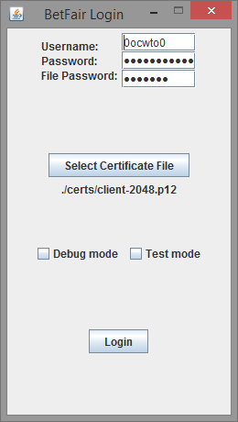

There is pre-entered log in details and the certificate file location already set. If user wants to use their own Betfair account then the certificate file should be set by pressing Select certificate file. A file chooser will open up and the user should select their own .p12 certificate file and change the log in details as necessary

The options on the log in view are debug (prints JSON requests + replies to console) and test mode. If test mode is selected then the log in doesn’t actually occur, it will just transfer the user to a test file selection view.

**Running on test data**

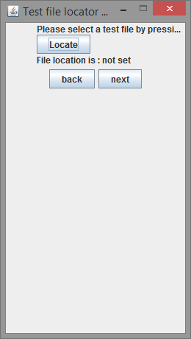

Instructions are to select a test file by pressing on the locate button.

In the logs provided the rawjson.txt file is the test file for the game. Some separate pre-labelled test files are in the directory provided under prepared_tests.

To run in test mode then press locate, select the file and press next.

**Selecting a sport**

Once logged in, a list of sports is provided. The program can be run on any sport but in order to test the actual project work, soccer should be selected

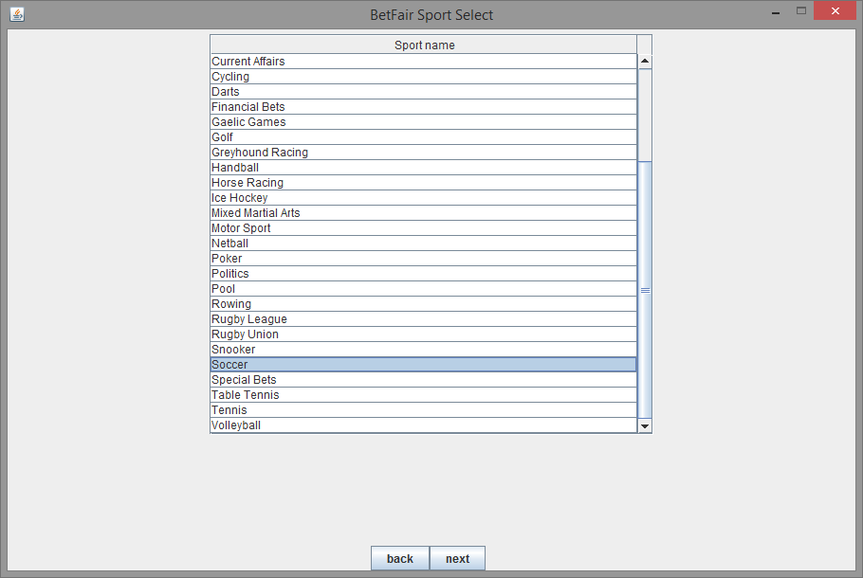

To proceed to game selection, after a sport is selected press next. If back is pressed it will return to the log in screen

**Selecting a game**

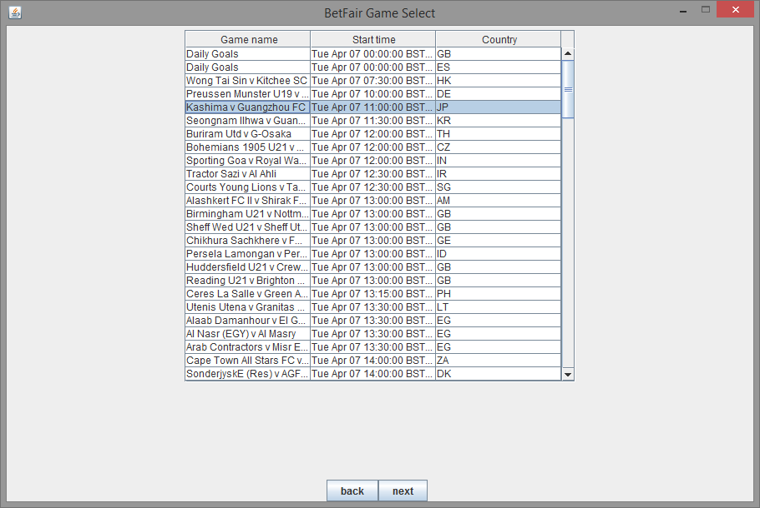

Simply select a game by its name and press next. Daily Goals which is listed above shouldn’t be selected, only actual games. Information provided the game start time and the country code for the game.

**Selecting market(s)**

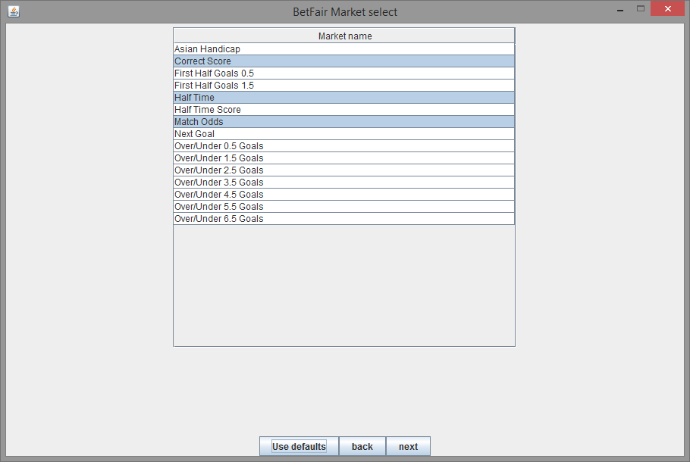

Any number of markets can be selected but to run the program under the designed markets, the use defaults button should be pressed, which will pre-select supported markets for the user.

Once markets are selected then the next button should be pressed to transition to the Analysis View

**Viewing the Analysis**

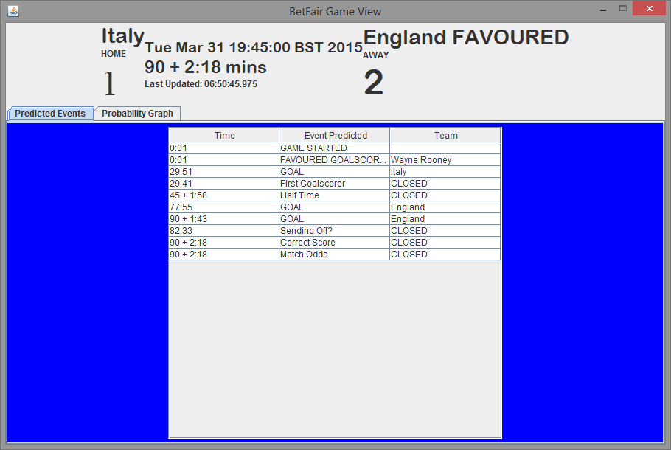

Only a test file is selected and next is pressed or markets are selected and next is pressed it will transfer you to an analysis view. If the game has not started yet then it will have filler text on the GUI until the game starts. Ideally all simulating is done via the test method since it will simulate a full football game in seconds, compared to waiting for the full duration.

# Appendix 10 Program Listing

The program listing and all log files are on the attached CD